
Oct – 2026
ASSIGNMENT – 2
Course Code : CSA43
Course Name : INTERNET PROGRAMMING
Max Marks: 50

Answer all the Questions

1 | Develop a JavaScript program using DOM manipulation and Regular Expressions to validate student name, email ID, mobile number and password during online registration. Display appropriate error messages without reloading the webpage. | (10) | (CO2) | (BL3)
2 | An e-commerce dynamic product search webpage using JavaScript DOM and AJAX for to Retrieve product details in JSON format from the server and display the matching products dynamically as the user enters a product name. | (10) | (CO2) | (BL4)
3 | Discuss the significance of the XMLHttpRequest object, its ready State properties and callback methods. Illustrate the working of AJAX using a suitable JavaScript program . | (10) | (CO2) | (BL3)
4 | An engineering college plans to develop a Student Management System using TypeScript to manage student information, including name, register number, department and marks. Develop a TypeScript program using a class and object to represent student details. Include properties, a constructor and a method to display student information. | (10) | (CO2) | (B4)
5 | Develop a JavaScript-based form validation system for an online banking application. Use Regular Expressions to validate account number, mobile number and email ID. | (10) | (CO1) | (BL3)

SIMATS ENGINEERING
ASSIGNMENT 2
Course Name | INTERNET PROGRAMMING
Course Code | CSA43
Name | B KIRTHANAA
Register Number | 192324244
Course Outcome Covered | CO-2 (Questions 1 to 4) and CO-1 (Question 5), as mapped in the assignment. CO-2 : Apply CSS layout and styling techniques to create visually appealing and responsive web interfaces, and use JavaScript to enable interactive client-side behavior. (L3)
Assessment Tool | Assignment 2 (Programming / Design Task)
Month | October 2026
Maximum Marks | 50 (5 questions x 10 marks)

Questions solved in this submission
- Question 1 (10 marks, CO2, BL3): student registration form validation with JavaScript DOM manipulation and regular expressions.
- Question 2 (10 marks, CO2, BL4): dynamic e-commerce product search with JavaScript DOM and AJAX using JSON data.
- Question 3 (10 marks, CO2, BL3): the XMLHttpRequest object, readyState values, callback methods and an AJAX program.
- Question 4 (10 marks, CO2, BL4): a Student Management System in TypeScript using a class, objects, a constructor and a method.
- Question 5 (10 marks, CO1, BL3): online banking form validation using regular expressions for account number, mobile number and email ID.

How the solutions are presented
Each question follows the same order. First I explain the problem and what it asks for, then the design, then the full code with a note on the important lines. After that come the output, the testing, an evaluation with possible improvements and a few viva questions with answers. I ran every program for this submission. The screenshots and terminal outputs under Output come from those runs, not from mock-ups.

Development Environment, Project Structure and How to Run
This assignment uses only plain web technologies. There is no framework and no external library, so the programs run on any computer that has a browser and Node.js. The browser runs the HTML, CSS and JavaScript. A very small Node.js server (server.js) plays the part of the "server" for the two AJAX questions, Question 2 and Question 3. It is needed because a browser will not let XMLHttpRequest or fetch read local files that were opened through a file:// address.

Software used
The pages are written in HTML5 and CSS3 and the logic in JavaScript (ES2020), which runs in the browser and in Node.js. Node.js v22.22.2 runs server.js, the regex test scripts and the compiled TypeScript. The TypeScript compiler tsc, version 6.0.3 in strict mode, compiles student.ts for Question 4. The pages were opened in Chromium 141 (headless) to capture the screenshots. Any text editor, for example VS Code, is enough for writing the source files.

Project structure
- server.js (Questions 2 and 3) is the static file server. It also answers the JSON and test endpoints /api/students, /api/slow, /api/error and /api/echo.
- q1/index.html, validators.js, app.js and test.js (Question 1) hold the registration form, the regular expressions and rules, the DOM and event code, and the regex test script.
- q2/index.html, search.js and products.json (Question 2) hold the search page, the AJAX and DOM code, and the product data in JSON format.
- q3/index.html and xhr-demo.js (Question 3) hold the XMLHttpRequest demonstration with its live readyState and event log.
- q4/student.ts and tsconfig.json (Question 4) hold the TypeScript Student and StudentManager classes and the compiler settings.
- q5/index.html, rules.js, ui.js and test.js (Question 5) hold the online banking form, the regular expressions and rules, the interface code and the test script.
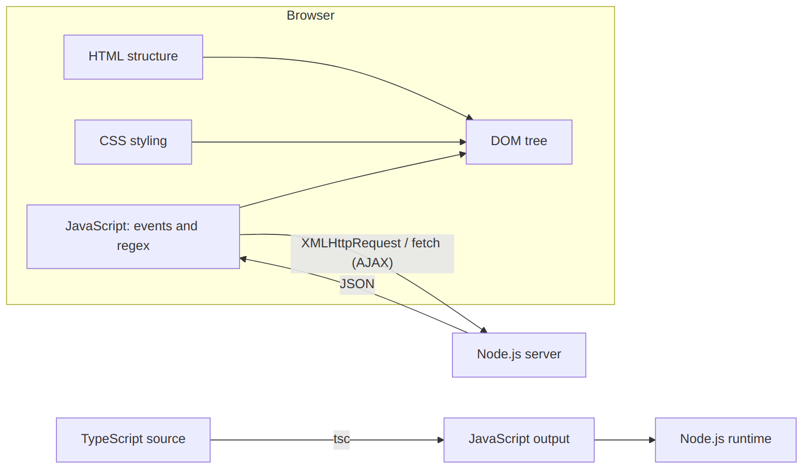
Figure 1: Overall architecture: browser (HTML, CSS, JavaScript), AJAX link to the Node.js server, and the TypeScript compile step

Question 1: Student Registration Validation using DOM and Regular Expressions
Question 1 | (10 marks) (CO2) (BL3)
Develop a JavaScript program using DOM manipulation and Regular Expressions to validate student name, email ID, mobile number and password during online registration. Display appropriate error messages without reloading the webpage.

SOLUTION:

(a) Understanding the problem and the requirements
A registration form collects data that the college system keeps and uses later. The name goes on records, the email ID and mobile number receive notices and one-time passwords, and the password protects the account. If a wrong value is accepted, the trouble shows up much later as messages that never arrive, logins that fail or records nobody can use. Form validation means checking each value against a rule before it is accepted. When the browser does the checking with JavaScript it is called client-side validation. The student gets an immediate and polite explanation, and the server is not bothered with a round trip for every typing mistake.
The question combines two techniques. DOM manipulation means the program reads the values from the form controls and then changes the page itself, for example by writing an error message or turning a border red or green. It does this through the Document Object Model, the tree of objects the browser builds from the HTML. Regular expressions are short patterns that describe what valid text looks like, such as "ten digits, the first one between 6 and 9". "Without reloading the webpage" means the form is never sent to the server to be checked. The submit event is intercepted, all the work happens in the same page and only the parts that need to change are updated.

Theory background
Kinds of validation checks. Checks can be grouped by what they test. A presence check makes sure a required field is not empty. A type check decides whether the value is made of the right kind of characters, for example digits only. A length check limits how short or long the value may be. A format check compares the value with a pattern, and this is where regular expressions are used. A consistency check compares two fields, as the confirm-password box does with the password. A good form uses several of these together, and each failed check should give its own message.
Client side and server side. Validation can run in two places. Client-side validation runs in the browser and gives instant feedback, but the user can switch off JavaScript or send a request without using the page at all, so it can never be trusted alone. Server-side validation runs after the data arrives and is the real safeguard. A well-built system uses both: the browser check for comfort and the server check for safety.
The DOM and the event model. The document is the root of the tree, html is its child, and body, form, div and input elements hang below it. Each node is an object with properties such as value, textContent and className and methods such as focus and setAttribute. When the student clicks or types, the browser creates an event object and runs the listeners registered for it. Listeners are added with addEventListener, which is better than inline attributes such as onclick because the HTML stays free of JavaScript and several listeners can share one element.
How a regular expression works. A regular expression is a small language for describing sets of strings. The engine reads the pattern and the text from left to right and tries to match one against the other. When a path fails it goes back and tries another route, which is called backtracking. Badly written patterns with nested repeats can become very slow on long input, and that is one reason every field here has a length limit. In JavaScript a pattern is written between slashes and the test() method returns true or false.

Requirements derived from the question
- R1 Student name. Handled by PATTERNS.name and RULES.fullName: letters only, 3 to 40 characters.
- R2 Email ID. Handled by PATTERNS.email and RULES.email: local part, the @ sign, a domain and a top-level domain.
- R3 Mobile number. Handled by PATTERNS.mobile and RULES.mobile: 10 digits, the first one between 6 and 9.
- R4 Password. Handled by PATTERNS.password and RULES.password: 8 to 20 characters from four character classes.
- R5 DOM manipulation. Done with getElementById, form.elements, textContent, classList.toggle and setAttribute.
- R6 Regular expressions. Four patterns that use anchors, character classes, quantifiers and lookaheads.
- R7 Appropriate error messages. A specific message for every kind of mistake, shown under the field.
- R8 No page reload. event.preventDefault() in the submit handler, and all feedback written into elements that already exist.

Concepts needed
The DOM. The browser turns the HTML into a tree. The form element is the parent of the div.field blocks, and each block holds a label, an input and a span for the error text. JavaScript reaches a node with a method such as document.getElementById("email") and then reads or writes its properties.
The program uses these DOM features. document.getElementById(id) finds the form, the message boxes and the strength meter. form.elements[id] and element.value read what the student typed. element.textContent writes plain text, so no HTML is interpreted, and classList.toggle(name, force) switches between the invalid and valid styles. setAttribute sets aria-invalid for screen readers, element.style.width changes the length of the strength bar, and element.focus() moves the cursor to the first wrong field. addEventListener(type, fn) registers the functions for blur, input, submit, change and reset.
Events. The program reacts to five events. blur fires when a field loses the cursor, so a field is judged only after the student has finished with it. input fires on every keystroke and gives live feedback once the field has been visited. submit fires when the Register button is pressed, change fires when the "Show passwords" box is ticked and reset fires when Clear is pressed.
Regular expressions. A regular expression (RegExp) is written between slashes. The symbols that appear in this program are explained below.
^ and $ mark the start and the end of the whole text. Without them a pattern could match a small part of a longer wrong value, so [6-9]\d{9} would accept a 12-digit number that happens to contain ten good digits. A character class such as [A-Za-z] matches any one character from the listed ranges, and a negated class [^...] matches any character that is not listed, which is how [^A-Za-z0-9\s] finds a special character. \d, \s and \S stand for a digit, a white-space character and a non-white-space character. The quantifiers +, * and ? mean one or more, zero or more and zero or one of the item before them, and {n} or {n,m} give an exact count or a range, as in \S{8,20}.
Parentheses make a group. A non-capturing group (?: ... ) groups without remembering the match, as in (?:\.[A-Za-z0-9-]+)*. A lookahead (?= ... ) checks that something follows the current position without using up characters, and (?! ... ) checks that it does not follow. So (?=.*\d) means "a digit exists somewhere ahead". A lookbehind (?<! ... ) looks backwards in the same way, as in (?<!\.)@. Finally test(text) is the RegExp method that returns true when the text matches, for example PATTERNS.mobile.test(v).

(b) Design of the solution

Validation rules for each field
- Student name. Letters only, 3 to 40 characters. Words may be joined by one space, dot, apostrophe or hyphen. Valid: B. Kirthanaa. Invalid: John123.
- Email ID. A local part, one @, a domain name and a top-level domain of at least 2 letters, with no leading, trailing or double dot. Valid: kirthanaa@saveetha.com. Invalid: kirthanaa@.
- Mobile number. Exactly 10 digits, and the first digit must be 6, 7, 8 or 9, as in Indian mobile numbers. Valid: 9876543210. Invalid: 5876543210.
- Password. 8 to 20 characters, no spaces, with at least one lowercase letter, one uppercase letter, one digit and one special character. Valid: Kirthu@2026. Invalid: kirthu2026.
- Confirm password. Must be identical to the password. Valid: Kirthu@2026 again. Invalid: Kirthu@2025.

The four regular expressions, symbol by symbol
The name pattern is ^(?=.{3,40}$)[A-Za-z]+(?:(?:\. ?|[ '-])[A-Za-z]+)*$.
Read from the left, the name pattern works like this. ^ starts the text. (?=.{3,40}$) is a lookahead that checks the whole text is 3 to 40 characters long without consuming anything. [A-Za-z]+ is the first word. (?: ... )* repeats zero or more further words, each made of a separator and letters. The separator (?:\. ?|[ '-]) is a dot with an optional space, as in "B. Kirthanaa", or one space, apostrophe or hyphen. Only one separator is allowed between words, which is why two spaces are rejected. $ ends the text.
The email pattern is ^(?!\.)(?!.*\.\.)[A-Za-z0-9._%+-]+(?<!\.)@[A-Za-z0-9-]+(?:\.[A-Za-z0-9-]+)*\.[A-Za-z]{2,}$.
The email pattern reads like this. (?!\.) says the address must not start with a dot, and (?!.*\.\.) rejects two dots in a row anywhere. [A-Za-z0-9._%+-]+ is the local part before the @ sign, and (?<!\.)@ requires that the character just before the @ is not a dot. [A-Za-z0-9-]+ is the first label of the domain, for example saveetha, (?:\.[A-Za-z0-9-]+)* allows more labels such as .co in mail.co.in, and \.[A-Za-z]{2,} ends with a dot and a top-level domain of at least two letters.
The mobile pattern is ^[6-9]\d{9}$, which means a first digit from 6 to 9 followed by exactly nine more digits. The password pattern is ^(?=.*[a-z])(?=.*[A-Z])(?=.*\d)(?=.*[^A-Za-z0-9\s])\S{8,20}$. It has four lookaheads, each scanning the whole text for one required kind of character, and then \S{8,20} accepts 8 to 20 characters that are not spaces. Lookaheads do not use up characters, so all four conditions are tested against the same text. That is how "at least one of each kind, in any order" is written.

Program design and flow
The solution is split into three files so each one has a single job. index.html holds the structure and the styles. validators.js has only plain functions and regular expressions and never touches the page, so it can be tested separately in Node.js. app.js is the only file that uses the DOM: it listens for events, calls the rules and shows the result. Every rule returns an empty string when the value is fine and an error message when it is not, so one function gives both the decision and the text.
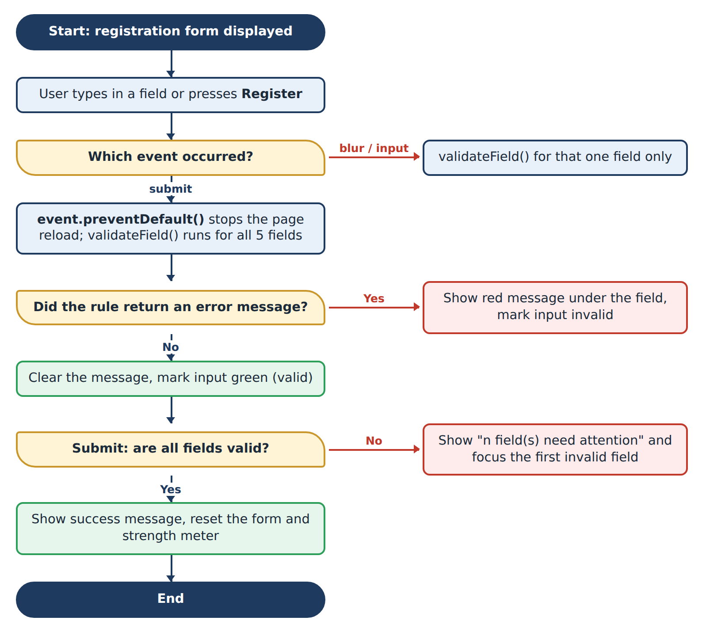
Figure 2: Flowchart of the validation logic (blur / input events and submit event)

User-interface decisions
- Each error is written directly under the field that caused it, in red and beside a red border, so the student never has to match a pop-up with a field.
- A field is not judged while it is being typed for the first time. The first check happens on blur. After that every keystroke re-checks the field, which gives live feedback.
- On submit all fields are checked together. A summary line says how many need attention and the cursor jumps to the first wrong one.
- The form carries the novalidate attribute so that the browser's own validation bubbles do not cover the custom messages.
- Every message area is marked aria-live="polite" and every input gets aria-invalid, so screen readers announce the errors.
- A password strength meter and a "Show passwords" check box help the student pick a good password and check what was typed.

(c) Implementation
The full source code is given below. It was run exactly as shown.
q1/index.html (structure and styles)
<!DOCTYPE html>
<html lang="en">
<head>
<meta charset="UTF-8">
<meta name="viewport" content="width=device-width, initial-scale=1.0">
<title>Student Registration</title>
<style>
* { box-sizing: border-box; margin: 0; padding: 0; }
body { font-family: Arial, sans-serif; background: #eef2f7; color: #1c2b3a;
display: flex; justify-content: center; padding: 28px 12px; }
.card { width: 100%; max-width: 460px; background: #fff; border-radius: 10px;
padding: 26px 28px; box-shadow: 0 2px 10px rgba(0,0,0,.15); }
h1 { font-size: 1.35rem; color: #1f3a5f; margin-bottom: 4px; }
.sub { font-size: .85rem; color: #5a6b7d; margin-bottom: 18px; }
.field { margin-bottom: 14px; }
label { display: block; font-size: .85rem; font-weight: bold; margin-bottom: 4px; }
input[type=text], input[type=email], input[type=tel], input[type=password] {
width: 100%; padding: 9px 10px; border: 1.5px solid #b8c3d1; border-radius: 6px;
font-size: .95rem; outline: none; }
input:focus { border-color: #1f3a5f; box-shadow: 0 0 0 3px rgba(31,58,95,.15); }
input.invalid { border-color: #d9534f; background: #fff6f6; }
input.valid { border-color: #2e9e5b; }
.error { display: block; min-height: 1.1em; margin-top: 3px; font-size: .78rem; color: #c0392b; }
.meter { height: 6px; background: #d0d7e2; border-radius: 3px; margin-top: 6px; overflow: hidden; }
#meterBar { height: 100%; width: 0; transition: width .25s ease; }
#meterText { font-size: .75rem; color: #5a6b7d; }
.row { display: flex; align-items: center; gap: 8px; font-size: .82rem; margin-bottom: 14px; }
.buttons { display: flex; gap: 10px; }
button { flex: 1; padding: 10px; border: 0; border-radius: 6px; font-size: .95rem;
cursor: pointer; background: #1f3a5f; color: #fff; }
button[type=reset] { background: #e1e7ef; color: #1f3a5f; }
#summary { color: #c0392b; font-size: .85rem; margin-bottom: 10px; min-height: 1.1em; }
#success { margin-top: 14px; padding: 10px 12px; background: #e6f6ec; color: #1d6b3d;
border: 1px solid #9ad5b0; border-radius: 6px; font-size: .9rem; }
</style>
</head>
<body>
<div class="card">
<h1>Student Online Registration</h1>
<p class="sub">All fields are mandatory.</p>

<form id="regForm" novalidate>
<div class="field">
<label for="fullName">Student Name</label>
<input type="text" id="fullName" name="fullName" placeholder="e.g. B. Kirthanaa" autocomplete="name">
<span class="error" id="fullNameError" aria-live="polite"></span>
</div>

<div class="field">
<label for="email">Email ID</label>
<input type="email" id="email" name="email" placeholder="name@example.com" autocomplete="email">
<span class="error" id="emailError" aria-live="polite"></span>
</div>

<div class="field">
<label for="mobile">Mobile Number</label>
<input type="tel" id="mobile" name="mobile" placeholder="10-digit number" maxlength="12" inputmode="numeric">
<span class="error" id="mobileError" aria-live="polite"></span>
</div>

<div class="field">
<label for="password">Password</label>
<input type="password" id="password" name="password" placeholder="8-20 characters" autocomplete="new-password">
<div class="meter"><div id="meterBar"></div></div>
<span id="meterText"></span>
<span class="error" id="passwordError" aria-live="polite"></span>
</div>

<div class="field">
<label for="confirmPassword">Confirm Password</label>
<input type="password" id="confirmPassword" name="confirmPassword" autocomplete="new-password">
<span class="error" id="confirmPasswordError" aria-live="polite"></span>
</div>

<div class="row">
<input type="checkbox" id="showPwd"> <label for="showPwd" style="margin:0;font-weight:normal">Show passwords</label>
</div>

<p id="summary" role="alert"></p>
<div class="buttons">
<button type="submit">Register</button>
<button type="reset">Clear</button>
</div>
</form>
<div id="success" role="status" hidden></div>
</div>

<script src="validators.js"></script>
<script src="app.js"></script>
</body>
</html>
q1/validators.js (regular expressions and rules)
"use strict";

/* Regular expressions used by the registration form */
const PATTERNS = {
// 3-40 chars, letters grouped in words; words are joined by ". " , ".", " ", "'" or "-"
name: /^(?=.{3,40}$)[A-Za-z]+(?:(?:\. ?|[ '-])[A-Za-z]+)*$/,

// local@domain.tld : no leading/trailing dot, no "..", TLD of 2+ letters
email: /^(?!\.)(?!.*\.\.)[A-Za-z0-9._%+-]+(?<!\.)@[A-Za-z0-9-]+(?:\.[A-Za-z0-9-]+)*\.[A-Za-z]{2,}$/,

// Indian mobile number: 10 digits, first digit 6-9
mobile: /^[6-9]\d{9}$/,

// 8-20 chars, no spaces, 1 lowercase, 1 uppercase, 1 digit, 1 special
password: /^(?=.*[a-z])(?=.*[A-Z])(?=.*\d)(?=.*[^A-Za-z0-9\s])\S{8,20}$/
};

/* Each rule returns "" when valid, otherwise a specific error message */
const RULES = {
fullName(value) {
const v = value.trim();
if (v === "") return "Student name is required.";
if (v.length < 3) return "Name must have at least 3 characters.";
if (v.length > 40) return "Name must not exceed 40 characters.";
if (!PATTERNS.name.test(v))
return "Use letters only; a space, dot, apostrophe or hyphen may separate words.";
return "";
},

email(value) {
const v = value.trim();
if (v === "") return "Email ID is required.";
if (!v.includes("@")) return "Email must contain the @ symbol.";
if (!PATTERNS.email.test(v)) return "Enter a valid email, for example name@example.com.";
return "";
},

mobile(value) {
const v = value.trim();
if (v === "") return "Mobile number is required.";
if (/\D/.test(v)) return "Mobile number must contain digits only.";
if (v.length !== 10) return "Mobile number must be exactly 10 digits.";
if (!PATTERNS.mobile.test(v)) return "Mobile number must start with 6, 7, 8 or 9.";
return "";
},

password(value) {
if (value === "") return "Password is required.";
if (/\s/.test(value)) return "Password must not contain spaces.";
if (value.length < 8 || value.length > 20) return "Password must be 8 to 20 characters long.";
if (!/[a-z]/.test(value)) return "Add at least one lowercase letter.";
if (!/[A-Z]/.test(value)) return "Add at least one uppercase letter.";
if (!/\d/.test(value)) return "Add at least one digit (0-9).";
if (!/[^A-Za-z0-9]/.test(value)) return "Add at least one special character such as @ # $ % !";
return "";
},

confirmPassword(value, passwordValue) {
if (value === "") return "Please re-enter the password.";
if (value !== passwordValue) return "Passwords do not match.";
return "";
}
};

/* Returns a score from 0 (empty) to 4 (strong) for the strength meter */
function passwordStrength(value) {
if (value === "") return 0;
let score = 0;
if (value.length >= 8) score++;
if (/[a-z]/.test(value) && /[A-Z]/.test(value)) score++;
if (/\d/.test(value)) score++;
if (/[^A-Za-z0-9]/.test(value)) score++;
return score;
}

if (typeof module !== "undefined") module.exports = { PATTERNS, RULES, passwordStrength };
q1/app.js (DOM manipulation and events)
"use strict";

const form = document.getElementById("regForm");
const fieldIds = ["fullName", "email", "mobile", "password", "confirmPassword"];
const summary = document.getElementById("summary");
const successBox = document.getElementById("success");
const meterBar = document.getElementById("meterBar");
const meterText = document.getElementById("meterText");

/* Show or clear the message of one field and style the input */
function setState(input, message) {
const errorSpan = document.getElementById(input.id + "Error");
errorSpan.textContent = message;
input.classList.toggle("invalid", message !== "");
input.classList.toggle("valid", message === "" && input.value !== "");
input.setAttribute("aria-invalid", String(message !== ""));
return message === "";
}

function validateField(input) {
const message = RULES[input.id](input.value, form.elements.password.value);
return setState(input, message);
}

function updateMeter() {
const labels = ["", "Weak", "Fair", "Good", "Strong"];
const colours = ["#d0d7e2", "#d9534f", "#f0ad4e", "#5bc0de", "#2e9e5b"];
const score = passwordStrength(form.elements.password.value);
meterBar.style.width = score * 25 + "%";
meterBar.style.background = colours[score];
meterText.textContent = score ? "Strength: " + labels[score] : "";
}

fieldIds.forEach(function (id) {
const input = form.elements[id];
let touched = false;

input.addEventListener("blur", function () {
touched = true;
validateField(input);
});

input.addEventListener("input", function () {
if (touched) validateField(input); // live feedback after first visit
if (id === "password") {
updateMeter();
const confirm = form.elements.confirmPassword;
if (confirm.value !== "") validateField(confirm);
}
});
});

document.getElementById("showPwd").addEventListener("change", function (e) {
const type = e.target.checked ? "text" : "password";
form.elements.password.type = type;
form.elements.confirmPassword.type = type;
});

form.addEventListener("submit", function (event) {
event.preventDefault(); // stop the page from reloading
let invalidCount = 0;
let firstInvalid = null;

fieldIds.forEach(function (id) {
const input = form.elements[id];
if (!validateField(input)) {
invalidCount++;
if (!firstInvalid) firstInvalid = input;
}
});

if (invalidCount > 0) {
summary.textContent = invalidCount + " field(s) need your attention.";
successBox.hidden = true;
firstInvalid.focus();
return;
}

summary.textContent = "";
successBox.textContent = "Registration successful. Welcome, " +
form.elements.fullName.value.trim() + "!";
successBox.hidden = false;
form.reset();
fieldIds.forEach(function (id) { setState(form.elements[id], ""); });
updateMeter();
});

form.addEventListener("reset", function () {
summary.textContent = "";
successBox.hidden = true;
setTimeout(function () {
fieldIds.forEach(function (id) { setState(form.elements[id], ""); });
updateMeter();
}, 0);
});

Explanation of the important statements
index.html
- <form id="regForm" novalidate> The form that groups the controls. novalidate switches off the default browser messages so that the program's own messages are used.
- <label for="email"> and <input id="email"> The for attribute links a label to its control; clicking the label focuses the input and screen readers read the label.
- <span class="error" id="emailError" aria-live="polite"> Empty place reserved for the message. The id is always the field id plus Error, which lets setState() find it automatically.
- type="tel", inputmode="numeric", maxlength="12" Shows the numeric keypad on phones; maxlength prevents very long input.
- autocomplete="new-password" Tells the browser that this is a new password so that it does not fill an old one.
- .invalid and .valid CSS classes Red border with light red background for wrong input and green border for correct input; applied by JavaScript.
- #meterBar { transition: width .25s ease } The strength bar grows smoothly when the width is changed from JavaScript.
- <script src="validators.js"> before app.js The order matters: app.js uses RULES and passwordStrength, so the file that defines them is loaded first.
validators.js
- const PATTERNS = { name: /.../, ... } All regular expressions are kept in one object, so each pattern is written once and has a single, meaningful name.
- fullName(value) { const v = value.trim(); ... } trim() removes spaces at both ends, so a name typed with a trailing space is accepted but a name of only spaces is reported as empty.
- if (v.length < 3) return "..." Early returns test one condition per line; the first failed condition decides the message.
- PATTERNS.name.test(v) The final regular-expression check. test() returns true or false.
- /\D/.test(v) in mobile \D means "any character that is not a digit". It finds letters and symbols and gives the clear message "digits only".
- if (/\s/.test(value)) in password Rejects spaces anywhere in the password.
- confirmPassword(value, passwordValue) Receives the current password as a second argument and compares the two strings with !==.
- passwordStrength(value) Adds one point for length of 8 or more, one for mixed case, one for a digit and one for a special character. The result 0 to 4 drives the meter.
- if (typeof module !== "undefined") module.exports = ... Lets Node.js import the file for testing. In a browser module does not exist, so the line is skipped and nothing breaks.
app.js
- const fieldIds = ["fullName", ...] List of the ids of the five inputs. Loops over this list avoid writing the same code five times.
- setState(input, message) The only place where the page is changed for a field: it writes the message into <id>Error, toggles invalid / valid and updates aria-invalid. It returns true when the message is empty.
- classList.toggle("valid", message === "" && input.value !== "") The green border is shown only when the field is correct and not empty, so an untouched field stays neutral.
- RULES[input.id](input.value, form.elements.password.value) Square brackets select the rule that has the same name as the field id. The second argument is used only by confirmPassword; the other rules ignore it.
- let touched = false inside the forEach callback A closure: every field keeps its own touched flag. Live checking starts only after the first blur.
- if (id === "password") { updateMeter(); ... } While typing the password the meter is refreshed and, if the confirm box already has text, it is re-validated because the match may have changed.
- event.preventDefault() Cancels the default action of the submit event, which would send the form and reload the page. This statement is the core of "without reloading".
- firstInvalid.focus() Puts the cursor in the first wrong field so the student can correct it immediately.
- form.reset() followed by setState(..., "") reset() clears the values; the loop then removes the green borders and messages.
- setTimeout(function () {...}, 0) in the reset handler The reset event is fired before the values are cleared, so the clean-up is postponed until the browser has finished resetting.

(d) Output
I opened the page in a browser and tried the following situations. Every figure is a screenshot of the running program.

1. The form when it is first opened
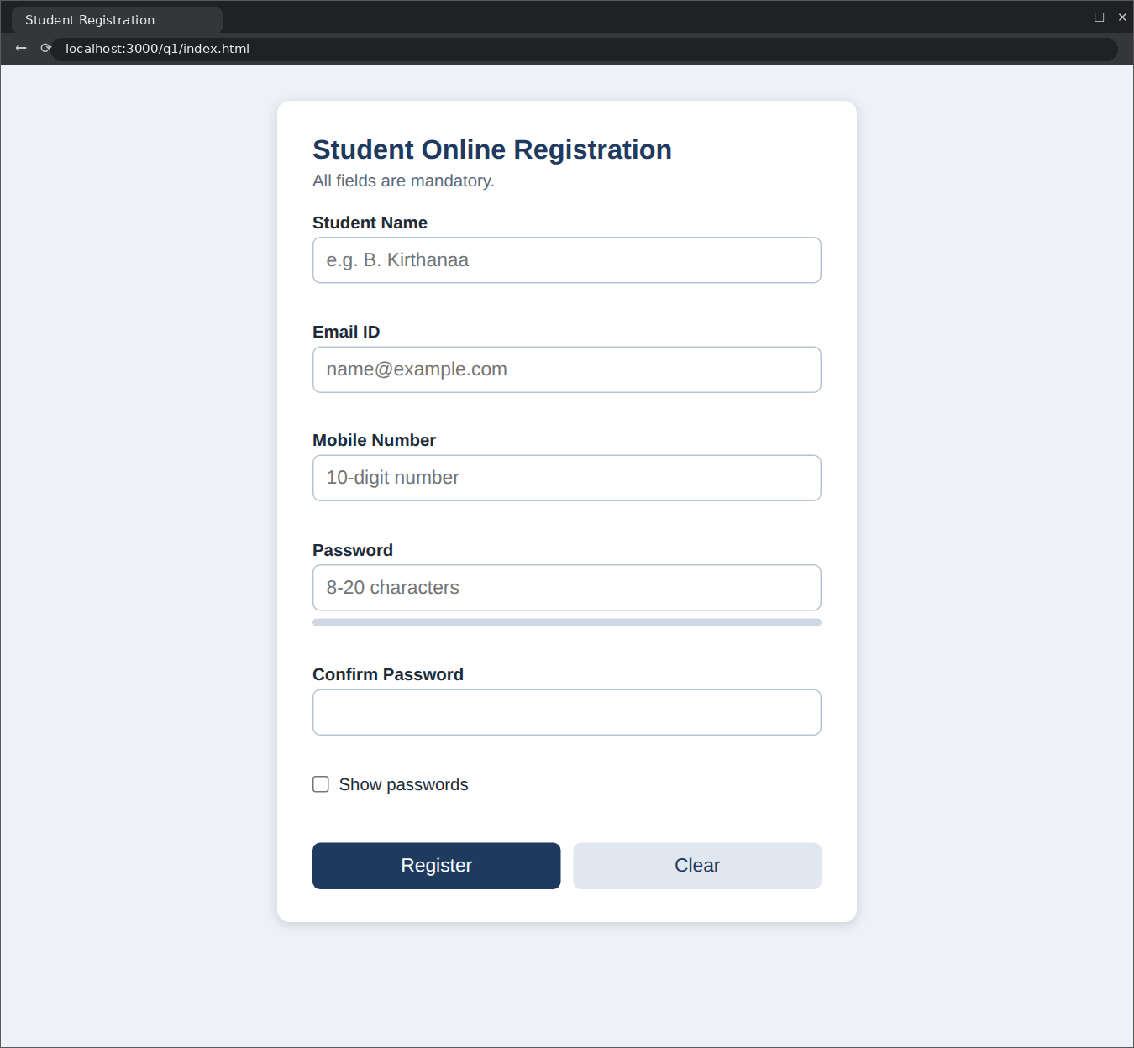
Figure 3: Registration form on first load: no messages, neutral borders, empty strength meter
Nothing is flagged for a field the student has not visited yet. A new visitor should not be greeted by a screen full of red text.

2. Pressing Register with an empty form
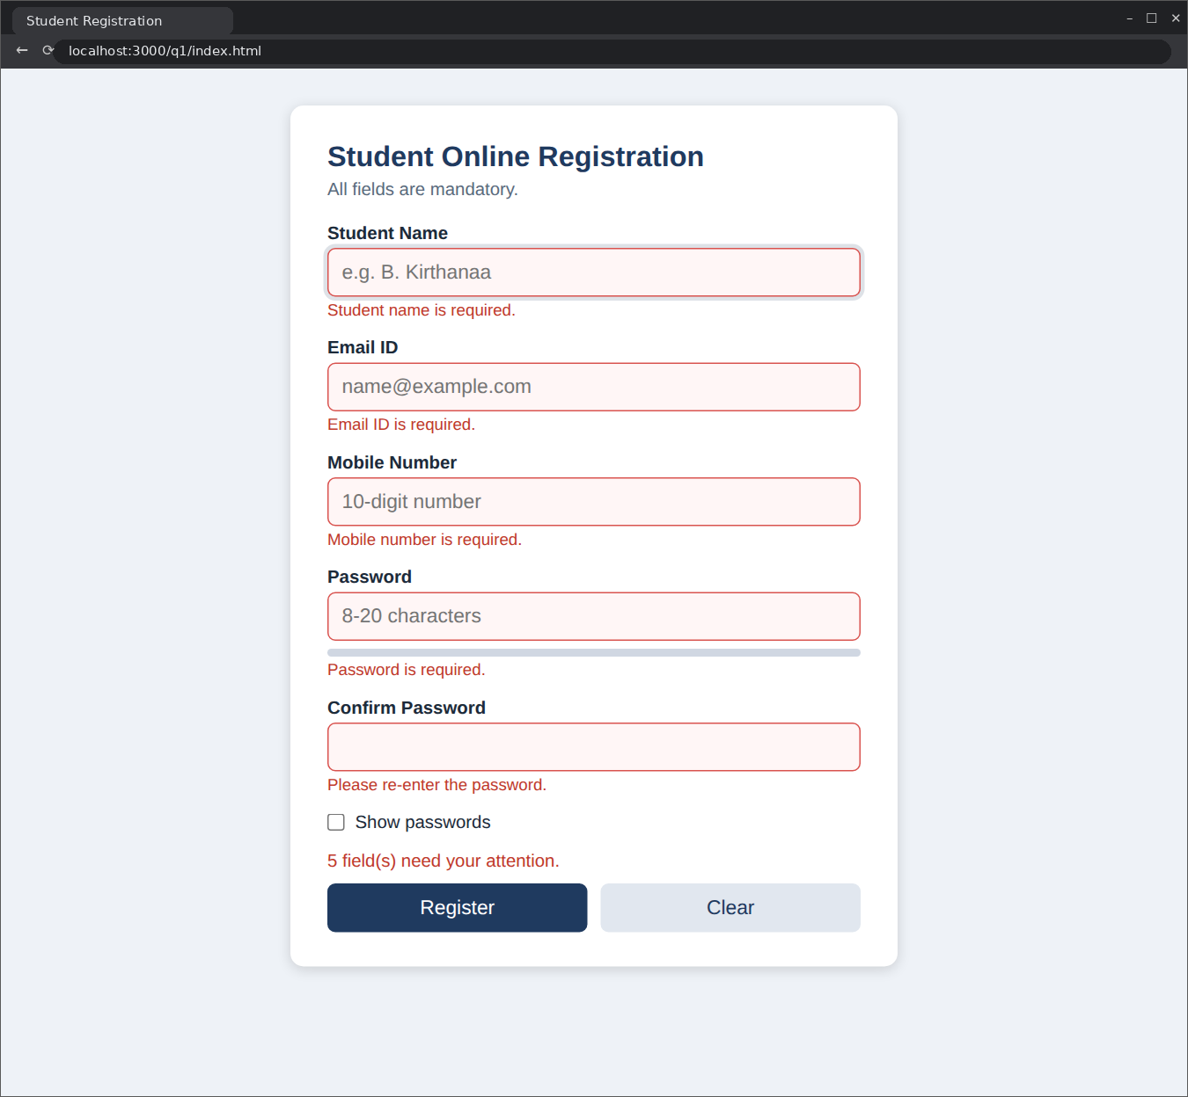
Figure 4: Submit with all fields empty: every field shows its "required" message and the summary line counts five fields
The submit handler checked all five fields at once. The line "5 field(s) need your attention." appears above the buttons and the cursor moved to the Student Name field. The address in the browser did not change and the page did not reload.

3. Entering invalid values
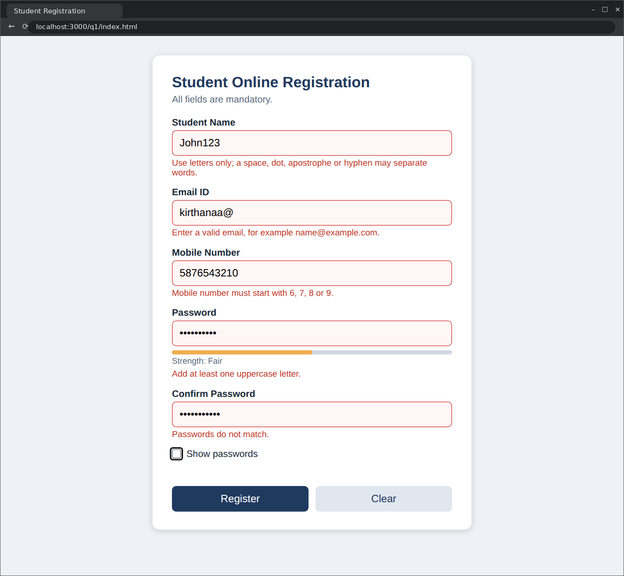
Figure 5: Invalid data: each field shows a message that explains the specific mistake
The values entered were John123 (digits in a name), kirthanaa@ (domain missing), 5876543210 (first digit 5), kirthu2026 (no uppercase letter and no special character) and a confirm password that does not match. Every field turned red and got its own message. The password message names only the first missing item, "Add at least one uppercase letter". The student fixes one item at a time and the message changes with every keystroke.

4. Password strength meter
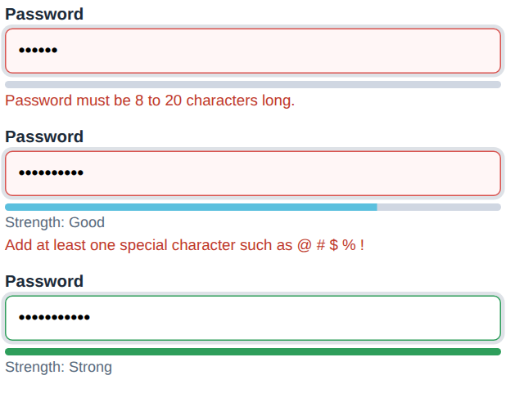
Figure 6: Strength meter for three passwords: kirthu (weak), Kirthu2026 (fair) and Kirthu@2026 (strong)
The bar fills from 25 to 100 percent and changes from red through orange to green as more of the four criteria are met.

5. Valid data before and after submitting
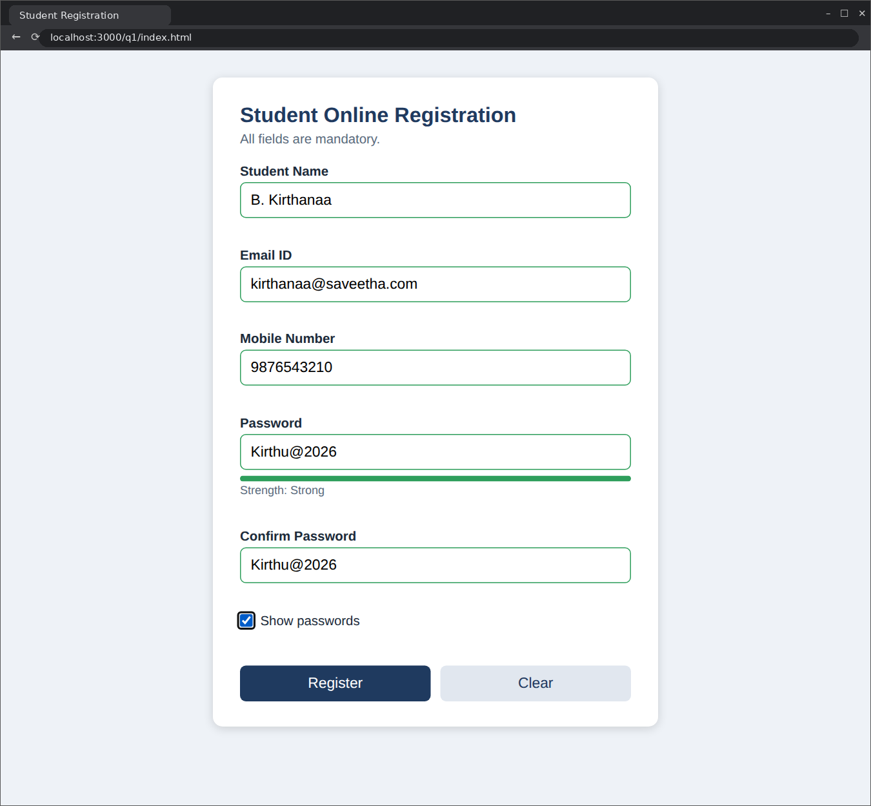
Figure 7: All fields correct: green borders, "Strong" meter and the passwords revealed with the check box
Figure 8: After pressing Register: success message appears and the form is cleared, without a page reload

6. Regular expression test run
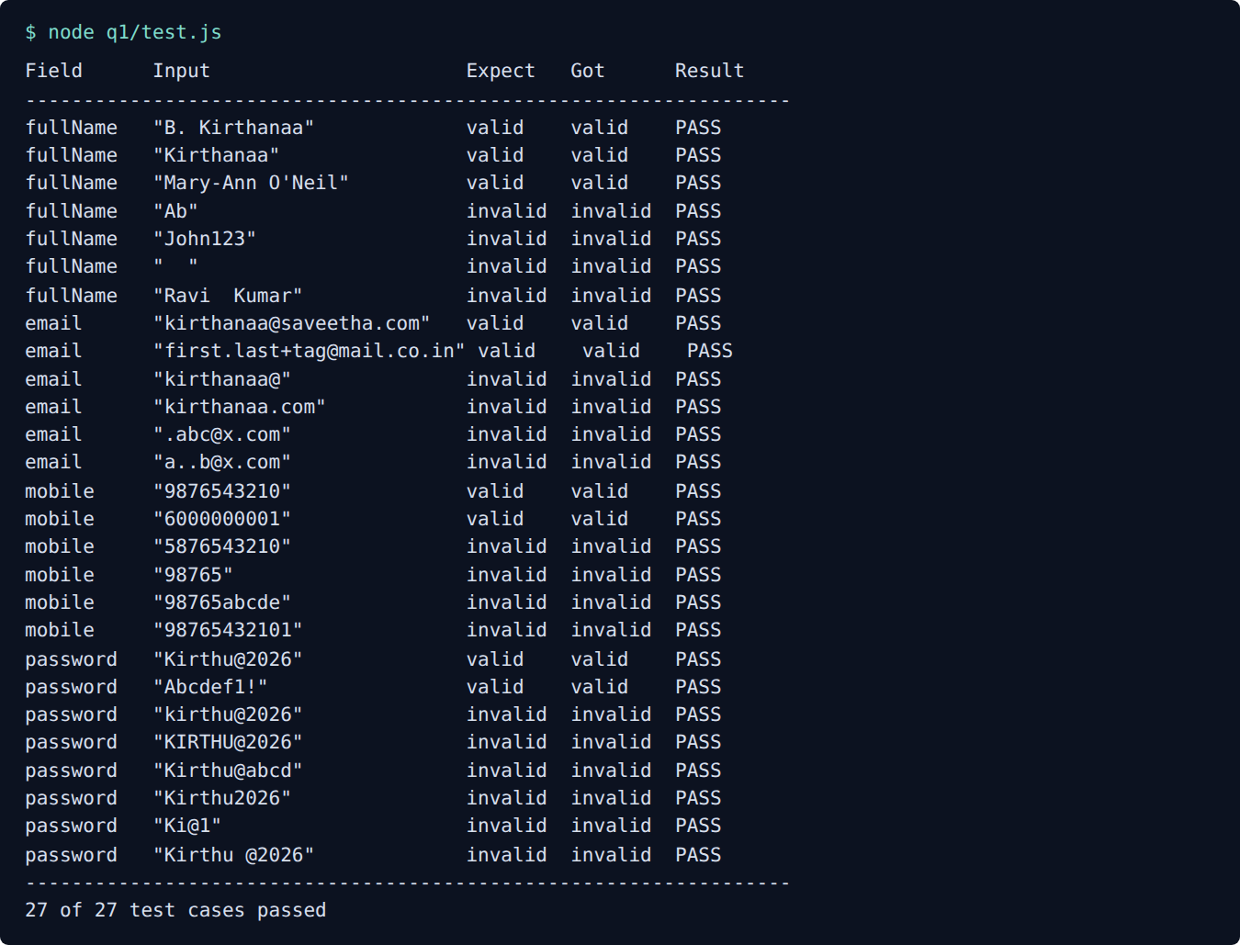
Figure 9: Output of node q1/test.js: 27 of 27 test cases passed

(e) Testing with valid and invalid data
The rules in validators.js do not depend on the page, so I tested them directly in Node.js with 27 inputs. The message for every rejected input was produced by the program itself. The results are grouped by field below.
- Student name (7 cases). Accepted: B. Kirthanaa, Kirthanaa, Mary-Ann O'Neil. Rejected: Ab gave “Name must have at least 3 characters.”; John123 gave “Use letters only; a space, dot, apostrophe or hyphen may separate words.”; (spaces only) gave “Student name is required.”; Ravi Kumar gave “Use letters only; a space, dot, apostrophe or hyphen may separate words.”.
- Email ID (6 cases). Accepted: kirthanaa@saveetha.com, first.last+tag@mail.co.in. Rejected: kirthanaa@ gave “Enter a valid email, for example name@example.com.”; kirthanaa.com gave “Email must contain the @ symbol.”; .abc@x.com gave “Enter a valid email, for example name@example.com.”; a..b@x.com gave “Enter a valid email, for example name@example.com.”.
- Mobile number (6 cases). Accepted: 9876543210, 6000000001. Rejected: 5876543210 gave “Mobile number must start with 6, 7, 8 or 9.”; 98765 gave “Mobile number must be exactly 10 digits.”; 98765abcde gave “Mobile number must contain digits only.”; 98765432101 gave “Mobile number must be exactly 10 digits.”.
- Password (8 cases). Accepted: Kirthu@2026, Abcdef1!. Rejected: kirthu@2026 gave “Add at least one uppercase letter.”; KIRTHU@2026 gave “Add at least one lowercase letter.”; Kirthu@abcd gave “Add at least one digit (0-9).”; Kirthu2026 gave “Add at least one special character such as @ # $ % !”; Ki@1 gave “Password must be 8 to 20 characters long.”; Kirthu @2026 gave “Password must not contain spaces.”.
Result: all 27 test cases gave the expected outcome.

(f) Evaluation and suggested improvements

Strengths
- Meets the question. Four fields are validated with regular expressions, messages are written with DOM methods and the page is never reloaded.
- Clear messages. The student learns what to change, not only that something is wrong.
- Separate concerns. The rules in validators.js do not depend on the DOM in app.js, so they can be tested, reused on a Node.js server and changed without touching the page.
- Safe output. Messages are written with textContent and never with innerHTML, so text typed by the user cannot inject HTML or script into the page.
- Accessible. Labels, aria-live regions, aria-invalid and a visible focus outline help keyboard and screen-reader users. Colour is never the only signal because the message text is always shown.
- Light on the browser. Only one small element changes per event, and there is no polling and no server request.

Limitations
- Client-side checks can be bypassed, for example with the browser developer tools or by sending a request directly, so they are not a security measure.
- The mobile rule accepts only 10-digit Indian numbers. International numbers need a different rule.
- An email address can have the right shape and still not exist. Only a confirmation mail can prove that it does.
- The strength meter counts character classes only, so it cannot tell that a common password such as Password@123 is weak.

Suggested improvements
- Repeat every rule on the server, return the same messages, and store only a hashed password (for example with bcrypt or Argon2).
- Check the password against a list of commonly used or leaked passwords.
- Send a verification link or OTP to prove that the email ID and mobile number belong to the student.
- Replace the five similar div.field blocks with a small function that builds a field from a description, so a new field needs one line.
- Add a country-code selector and use a phone-number library for international numbers.
- Disable the Register button while a request is in progress and show a spinner when the form is sent to the server by AJAX.
- Move the messages to a language file so the form can be shown in Tamil, Hindi or English.

Question 2: Dynamic Product Search using DOM and AJAX (JSON)
Question 2 | (10 marks) (CO2) (BL4)
An e-commerce dynamic product search webpage using JavaScript DOM and AJAX for to Retrieve product details in JSON format from the server and display the matching products dynamically as the user enters a product name.
SOLUTION:

(a) Understanding the problem and the requirements
On an online shop most customers do not walk through every category. They type a few letters into a search box and expect the matching products to appear straight away. A page that reloads for every search feels slow and loses the customer's place. The question therefore asks for a search page that gets the product details from the server in JSON format and shows the matching products while the user is still typing, without refreshing the page.

Theory background
AJAX. AJAX stands for Asynchronous JavaScript and XML. It is a technique and not a language or a library. JavaScript sends an HTTP request in the background, carries on with other work and handles the reply when it arrives. "Asynchronous" means the page stays usable while the request is on its way, so the user can keep typing, scrolling or clicking. The word XML in the name is historical, because today most servers reply in JSON.
JSON. JavaScript Object Notation is a light text format for data. It is built from objects written as {"name": "value"}, arrays written as [ ... ], strings, numbers, true, false and null. Compared with XML it is shorter, easier to read and maps directly onto JavaScript objects. JSON.parse() turns JSON text into a JavaScript value and JSON.stringify() does the reverse. With fetch, the call response.json() does the parsing.
The fetch API and promises. fetch() is the modern way to make a request. It returns a promise, which is an object that stands for a value that will arrive later. A promise is pending at first and then either fulfilled with a value or rejected with an error. The result can be handled with .then() or, more readably, with async and await. One detail often surprises beginners: fetch rejects only when the network fails. An HTTP reply such as 404 or 500 still counts as a fulfilled promise, so the code must test response.ok itself.
Showing the result with the DOM. The matching products are turned into elements with document.createElement, text is added with textContent and the elements are attached with appendChild. A DocumentFragment is a light container that lets all the rows be built off-screen and added to the page in one step, so the browser redraws once. Text from the server is always written with textContent and not innerHTML, because a product name that contains HTML could otherwise run script in the page. This kind of attack is called cross-site scripting (XSS).
Search as you type. Sending a request on every key press wastes the network, and the replies can arrive in the wrong order. Two small techniques solve this. Debouncing waits until the user pauses for a moment (250 ms here) before the search runs. Aborting cancels the older request with an AbortController when a newer search starts, so a slow old reply can never overwrite a newer one.

Requirements derived from the question
- Read product details from a file in JSON format instead of writing them inside the HTML.
- Use AJAX (fetch) so that the page is never reloaded.
- Show the matching products dynamically while the user types a product name.
- Build the result list with DOM methods, and show a clear message when nothing matches or the server cannot be reached.

(b) Design of the solution
The data flow is short. The user types in the search box, the input event fires, and a timer waits 250 ms. If nothing else is typed in that time, fetch asks the server for products.json. The reply is parsed into an array, the products whose name contains the typed text (ignoring upper and lower case) are selected, and the DOM is rebuilt with those products. A status line above the list reports what happened: searching, how many products were found, nothing found, or an error.
Each product in the JSON file is an object with an id, a name, a category, a price and a stock count, for example { "id": 1, "name": "Wireless Mouse", "category": "Accessories", "price": 599, "stock": 24 }. The file holds ten products, so the whole list is small enough to be fetched and filtered in the browser for this assignment. A real shop with thousands of products would send the typed text to the server, for example as /api/products?q=wire, and let the server do the filtering.
On the screen the matching part of each name is highlighted, the price is shown in rupees with Indian digit grouping, and a product with no stock is marked "Out of stock" in red. The status line is an aria-live region so that screen readers announce the result count.

(c) Implementation
The complete source code is given below. The server that delivers these files is server.js, listed under Question 3.
q2/index.html (structure and styles)
<!DOCTYPE html>
<html lang="en">
<head>
<meta charset="UTF-8">
<meta name="viewport" content="width=device-width, initial-scale=1">
<title>Product Search</title>
<style>
body { font-family: Arial, sans-serif; background: #f4f6fa; margin: 0; padding: 24px; }
.box { max-width: 640px; margin: auto; background: #fff; padding: 20px 24px; border-radius: 8px; border: 1px solid #d5dbe6; }
h1 { font-size: 20px; color: #1f3a5f; margin-top: 0; }
input { width: 100%; padding: 10px; font-size: 15px; box-sizing: border-box; border: 1px solid #9aa5b8; border-radius: 4px; }
#status { margin: 10px 0; color: #555; font-size: 14px; min-height: 18px; }
.item { display: flex; justify-content: space-between; padding: 10px 4px; border-bottom: 1px solid #e3e7ef; }
.item small { color: #666; display: block; }
.price { font-weight: bold; color: #1f3a5f; }
.out { color: #b00020; font-size: 12px; }
mark { background: #ffe98a; }
</style>
</head>
<body>
<div class="box">
<h1>Product Search</h1>
<input id="q" type="text" placeholder="Type a product name, for example: wire" autocomplete="off">
<div id="status" aria-live="polite"></div>
<div id="results"></div>
</div>
<script src="search.js"></script>
</body>
</html>
q2/search.js (AJAX, JSON and DOM code)
// Dynamic product search: DOM + AJAX (fetch) + JSON
const box = document.getElementById("q");
const statusLine = document.getElementById("status");
const results = document.getElementById("results");

let timer = null;
let controller = null;

function escapeRegExp(text) {
return text.replace(/[.*+?^${}()|[\]\\]/g, "\\$&");
}

function show(products, term) {
results.textContent = "";
const frag = document.createDocumentFragment();
const re = new RegExp("(" + escapeRegExp(term) + ")", "ig");
products.forEach(p => {
const row = document.createElement("div");
row.className = "item";

const left = document.createElement("div");
const title = document.createElement("span");
// build the name with a highlighted match, without using innerHTML
p.name.split(re).forEach(part => {
if (part.toLowerCase() === term.toLowerCase()) {
const m = document.createElement("mark");
m.textContent = part;
title.appendChild(m);
} else {
title.appendChild(document.createTextNode(part));
}
});
const small = document.createElement("small");
small.textContent = p.category + (p.stock === 0 ? "" : " | " + p.stock + " in stock");

left.appendChild(title);
left.appendChild(small);
if (p.stock === 0) {
const out = document.createElement("span");
out.className = "out";
out.textContent = "Out of stock";
left.appendChild(out);
}

const price = document.createElement("div");
price.className = "price";
price.textContent = "Rs. " + p.price.toLocaleString("en-IN");

row.appendChild(left);
row.appendChild(price);
frag.appendChild(row);
});
results.appendChild(frag);
}

async function search(term) {
if (controller) controller.abort(); // cancel the older request
controller = new AbortController();
statusLine.textContent = "Searching...";
try {
const response = await fetch("/q2/products.json", { signal: controller.signal });
if (!response.ok) throw new Error("Server replied " + response.status);
const all = await response.json(); // JSON text -> JavaScript array
const found = all.filter(p => p.name.toLowerCase().includes(term.toLowerCase()));
if (found.length === 0) {
results.textContent = "";
statusLine.textContent = "No product matches \"" + term + "\".";
} else {
show(found, term);
statusLine.textContent = found.length + " product(s) found for \"" + term + "\".";
}
} catch (err) {
if (err.name === "AbortError") return; // a newer search replaced this one
results.textContent = "";
statusLine.textContent = "Could not load products: " + err.message;
}
}

box.addEventListener("input", () => {
clearTimeout(timer); // debounce: wait until typing pauses
const term = box.value.trim();
if (term === "") {
results.textContent = "";
statusLine.textContent = "";
return;
}
timer = setTimeout(() => search(term), 250);
});
q2/products.json (product data in JSON format)
[
{ "id": 1, "name": "Wireless Mouse", "category": "Accessories", "price": 599, "stock": 24 },
{ "id": 2, "name": "Mechanical Keyboard", "category": "Accessories", "price": 3499, "stock": 9 },
{ "id": 3, "name": "USB-C Charger 65W", "category": "Chargers", "price": 1299, "stock": 40 },
{ "id": 4, "name": "Bluetooth Headphones", "category": "Audio", "price": 2199, "stock": 15 },
{ "id": 5, "name": "Laptop Stand", "category": "Accessories", "price": 899, "stock": 0 },
{ "id": 6, "name": "Smart Watch", "category": "Wearables", "price": 4999, "stock": 12 },
{ "id": 7, "name": "Power Bank 20000mAh", "category": "Chargers", "price": 1799, "stock": 31 },
{ "id": 8, "name": "Webcam HD", "category": "Accessories", "price": 1599, "stock": 7 },
{ "id": 9, "name": "Portable Speaker", "category": "Audio", "price": 1999, "stock": 18 },
{ "id": 10, "name": "Wireless Earbuds", "category": "Audio", "price": 2799, "stock": 22 }
]

Explanation of the important statements
- let timer = null; let controller = null; keep the pending debounce timer and the current AbortController between calls, so the next call can cancel them.
- escapeRegExp(text) puts a backslash before characters such as + and ., so a user who types c++ does not break the regular expression that is used for highlighting.
- p.name.split(re) cuts the name at every match, because re has a capturing group. The loop then writes plain text nodes and <mark> elements, which highlights the match without using innerHTML.
- controller.abort() cancels the previous request when a newer search starts. The cancelled fetch rejects with an AbortError, and the catch block ignores that error on purpose.
- const response = await fetch("/q2/products.json", { signal }) sends the request and waits for the reply headers without freezing the page.
- if (!response.ok) throw new Error(...) turns an HTTP error such as 500 into a real error, because fetch would not do it by itself.
- const all = await response.json(); reads the body and parses the JSON text into an array of objects.
- all.filter(p => p.name.toLowerCase().includes(term.toLowerCase())) keeps the products whose name contains the typed text, ignoring case.
- document.createDocumentFragment() collects all the rows so that they are added to the page together.
- setTimeout(() => search(term), 250) after clearTimeout(timer) is the debounce: only the last key press in a burst starts a search.

(d) Output
The page was opened through the Node.js server and the following searches were tried. Every figure is a screenshot of the running program.

1. The page when it is first opened
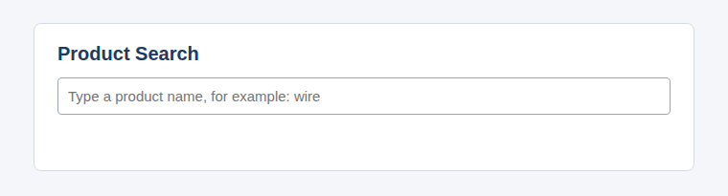
Figure 10: The search page on first load: an empty box, no status message and no products
The page starts empty. Products are shown only after the user types something, so no request is made until it is needed.

2. Searching for "wire"
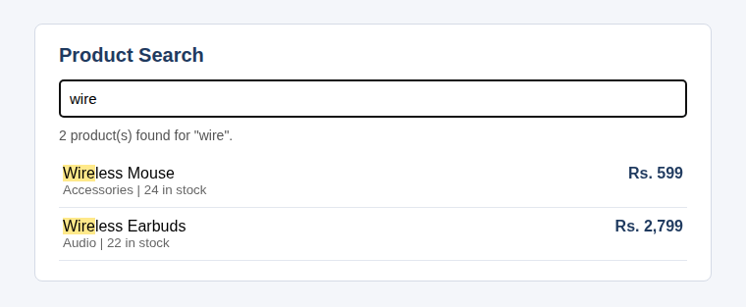
Figure 11: Typing wire: two matching products, with the matching letters highlighted
Wireless Mouse and Wireless Earbuds were returned. The status line says "2 product(s) found" and the typed letters are highlighted inside each name. The page did not reload.

3. A product that is out of stock
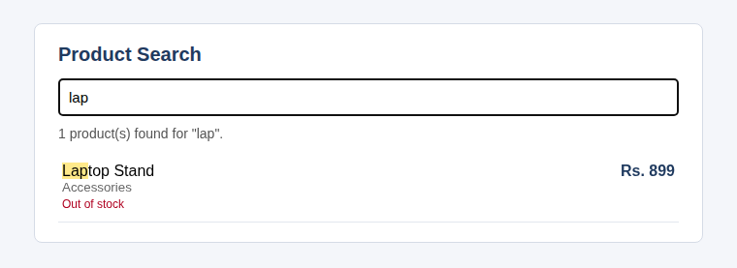
Figure 12: Typing lap: Laptop Stand is listed and marked Out of stock

4. A search with no match
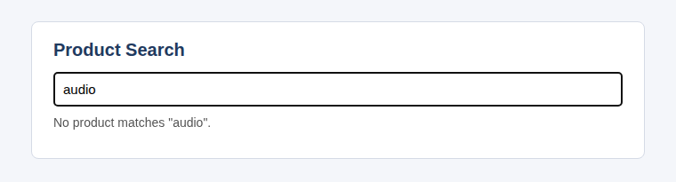
Figure 13: Typing audio: no product name contains it, so the status line says so
The word "audio" is a category and not part of any product name, so nothing matches. The search is on the product name, and the page says clearly that nothing was found instead of staying blank.

(e) Testing with valid and invalid data
I tested the page in a real browser by typing into the search box and reading the status line and the number of rows. The results were as follows.
- wire returned 2 products and WIRE also returned 2, so the search ignores letter case.
- usb returned 1 product (USB-C Charger 65W). The single letters a and e returned 9 and 8 products, which agrees with a count made by hand from the JSON file.
- c++ and xyz returned no products and the message "No product matches". The page did not crash on the special characters in c++.
- A box that contains only spaces, or is cleared, empties the list and the status line.
- Typing wireless quickly, one letter every 40 ms, sent exactly 1 request to the server because of the debounce, and the final status was "2 product(s) found".
- When the server answered 500 for products.json, the status line showed "Could not load products: Server replied 500".
- When the network request was blocked, the status line showed "Could not load products: Failed to fetch".

(f) Evaluation and suggested improvements

Strengths
- The page meets every part of the question: JSON data, AJAX with fetch, DOM updates while typing and no reload.
- Debouncing and aborting keep the network quiet and stop old replies from overwriting new ones.
- All text from the data is written with textContent, so a product name cannot inject HTML into the page.
- The empty, no-match and error cases each have a clear message.

Limitations
- The browser downloads the whole product list and filters it itself. That is fine for ten products and wasteful for ten thousand.
- The search matches only the product name. It does not handle spelling mistakes or look at the category.
- Results are not sorted by relevance and there is no paging.

Suggested improvements
- Send the typed text to the server (/api/products?q=...) and let it filter, using URLSearchParams to build the address safely.
- Cache recent searches in memory so repeated searches need no request.
- Add arrow-key navigation through the results and a category filter.
- Show a loading indicator for slow connections and a retry button after an error.

Question 3: XMLHttpRequest, readyState Properties and Callback Methods
Question 3 | (10 marks) (CO2) (BL3)
Discuss the significance of the XMLHttpRequest object, its ready State properties and callback methods. Illustrate the working of AJAX using a suitable JavaScript program .
SOLUTION:

(a) Understanding the problem and the requirements
The question has two parts. The first asks for a discussion: why the XMLHttpRequest object matters, what its readyState values mean and which callback methods it offers. The second asks for a working JavaScript program that shows AJAX in action. This section covers the theory, and the program is built in the sections that follow.

The traditional page cycle and the AJAX cycle
In the traditional model every click on a link or a form button asks the server for a whole new page. The browser throws away the old page, waits, and draws the new one. Even a tiny change, such as a new comment count, costs a complete reload. With AJAX the page stays where it is. JavaScript sends a request in the background, the server replies with only the data that is needed, and JavaScript updates the one part of the page that changed. Search suggestions, live scores, chat windows and "like" buttons all work this way.

Significance of the XMLHttpRequest object
XMLHttpRequest, usually shortened to XHR, is the built-in browser object that lets JavaScript make HTTP requests. Microsoft first used it in Internet Explorer 5 in 1999 so that Outlook Web Access could update the page without reloading, and other browsers copied it. It is now defined by the WHATWG XMLHttpRequest standard and is the base on which AJAX was built.
Its importance can be put in a few points. It lets a page exchange data with the server without a reload, which makes web applications feel like desktop programs. It works asynchronously, so the user interface does not freeze while the server is thinking. It can send and receive text, JSON, XML, HTML and binary data, and it supports every HTTP method, although GET and POST are the most common. It also reports progress, errors and timeouts through events, and a request that is no longer wanted can be cancelled. It works in every browser, including very old ones, which is why a lot of existing code and libraries still rely on it.

Main properties and methods
Properties. readyState holds the current stage of the request, from 0 to 4. status is the HTTP status code of the reply, such as 200 or 404, and statusText is its text, such as "OK". responseText holds the reply as a string and responseXML holds it as an XML document when the reply is XML. response together with responseType gives the reply as JSON, a blob or an array buffer. timeout sets how many milliseconds to wait before giving up, and withCredentials decides whether cookies are sent with a cross-site request.
Methods. open(method, url, async) sets up the request but sends nothing. send(body) sends it, with null for a GET request or the data for a POST request. setRequestHeader(name, value) adds a header such as Content-Type, and it must be called after open and before send. getResponseHeader(name) and getAllResponseHeaders() read the headers of the reply. abort() cancels the request.

The readyState values
A request moves through five stages, and the readyState property tells which one it has reached.
- 0, UNSENT. The object has been created with new XMLHttpRequest() but open() has not been called yet.
- 1, OPENED. open() has been called. The method and address are set, and headers can still be added before send().
- 2, HEADERS_RECEIVED. send() has been called and the server's status line and headers have arrived. status and the headers can now be read.
- 3, LOADING. The body of the reply is arriving, and responseText holds the part received so far.
- 4, DONE. The operation is complete. The whole reply has arrived, or the request has failed, timed out or been aborted.
A request that fails early can jump straight from 1 to 4. The timeout test in the output section shows exactly that. Also note that the value 4 means the request has finished, not that it has succeeded. The program must still look at status to find out whether the server accepted it.

Callback methods (event handlers)
A callback is a function that the browser calls when something happens. XHR offers these handlers.
- onreadystatechange runs every time readyState changes. It is the oldest handler and runs at every stage, so it is usually combined with a test such as readyState === 4.
- onloadstart runs when the request starts, and onprogress runs while data is being received, which makes a progress bar possible.
- onload runs when the request has completed and a reply has arrived. It runs for 404 and 500 replies as well, so the code must check status.
- onerror runs when the request fails at network level, for example when the server cannot be reached.
- ontimeout runs when the time set in timeout has passed without a reply, and onabort runs after abort() is called.
- onloadend runs last in every case, whether the request succeeded, failed, timed out or was aborted. It is a good place for clean-up such as hiding a spinner.

HTTP status codes
The status value tells how the server dealt with the request. Codes from 200 to 299 mean success (200 OK, 201 Created). Codes from 300 to 399 are redirects. Codes from 400 to 499 are errors made by the client, such as 404 Not Found or 403 Forbidden. Codes from 500 to 599 are errors on the server, such as 500 Internal Server Error. A request with status 0 never got a proper reply, which happens after a network failure, a timeout or an abort.

GET and POST, asynchronous and synchronous
GET asks for data. Its parameters travel in the address, it should not change anything on the server, and the browser may cache it. POST sends data in the body of the request, for example a form or a JSON object, and is used when something is created or changed. The third argument of open() chooses between asynchronous (true) and synchronous (false) mode. A synchronous request freezes the page until the reply comes, so browsers have deprecated it on the main thread and this program always uses asynchronous requests.

Requirements derived from the question
- Explain the significance of XMLHttpRequest, its readyState values and its callback methods (covered above).
- Write a JavaScript program that makes real AJAX requests with XMLHttpRequest.
- Show every readyState and every callback in action, including the failure cases, so that the theory is proved by output.

(b) Design of the solution
The demonstration page has five buttons. GET students asks the server for a JSON list. POST data sends a small JSON object and receives it back. 404 request asks for an address that does not exist. 500 request asks for an address that always fails on the server. Timeout (1 s) asks for an address that answers after 3 seconds, while the page is only willing to wait 1 second.
A single function, send(method, path, body, timeout), does the work for all five buttons. It creates a new XMLHttpRequest, attaches all the handlers, and writes one line to an event log every time a handler runs. The log is shown on the page in a dark box, so the order of the events can be read directly. The area above the log shows the data that came back, or a message about the failure.
The server is the small Node.js program server.js. It serves the static files and offers four test addresses: /api/students returns a JSON list, /api/echo returns what was posted, /api/error always answers 500, and /api/slow waits 3 seconds before it replies.

(c) Implementation
The complete source code is given below.
q3/index.html (structure and styles)
<!DOCTYPE html>
<html lang="en">
<head>
<meta charset="UTF-8">
<title>XMLHttpRequest Demo</title>
<style>
body { font-family: Arial, sans-serif; background: #f4f6fa; margin: 0; padding: 24px; }
.box { max-width: 720px; margin: auto; background: #fff; padding: 20px 24px; border-radius: 8px; border: 1px solid #d5dbe6; }
h1 { font-size: 20px; color: #1f3a5f; margin-top: 0; }
button { padding: 8px 14px; margin: 0 6px 8px 0; border: 1px solid #1f3a5f; background: #1f3a5f; color: #fff; border-radius: 4px; cursor: pointer; }
button.light { background: #fff; color: #1f3a5f; }
pre { background: #10151f; color: #d8e2f0; padding: 12px; border-radius: 6px; min-height: 140px; font-size: 13px; white-space: pre-wrap; }
#data { background: #eef3fa; padding: 10px; border-radius: 6px; min-height: 40px; font-size: 14px; }
</style>
</head>
<body>
<div class="box">
<h1>XMLHttpRequest: live readyState and event log</h1>
<button id="get">GET students</button>
<button id="post" class="light">POST data</button>
<button id="missing" class="light">404 request</button>
<button id="fail" class="light">500 request</button>
<button id="slow" class="light">Timeout (1 s)</button>
<div id="data">Response data will appear here.</div>
<h3>Event log</h3>
<pre id="log"></pre>
</div>
<script src="xhr-demo.js"></script>
</body>
</html>
q3/xhr-demo.js (XMLHttpRequest and callbacks)
// AJAX with the XMLHttpRequest object
const log = document.getElementById("log");
const data = document.getElementById("data");
const names = ["UNSENT", "OPENED", "HEADERS_RECEIVED", "LOADING", "DONE"];

function write(line) { log.textContent += line + "\n"; }

function send(method, path, body, timeout) {
log.textContent = "";
data.textContent = "Waiting for the server...";
const xhr = new XMLHttpRequest(); // readyState 0
write("readyState " + xhr.readyState + " (" + names[xhr.readyState] + ") new XMLHttpRequest()");

xhr.onreadystatechange = function () {
write("readyState " + xhr.readyState + " (" + names[xhr.readyState] + ") status=" + xhr.status);
};
xhr.onload = function () {
write("onload status " + xhr.status + " " + xhr.statusText);
if (xhr.status >= 200 && xhr.status < 300) {
data.textContent = xhr.responseText;
} else {
data.textContent = "Server reported an error: " + xhr.status;
}
};
xhr.onerror = function () { write("onerror network failure"); data.textContent = "Network error"; };
xhr.ontimeout = function () { write("ontimeout no reply within " + xhr.timeout + " ms"); data.textContent = "The request timed out."; };
xhr.onloadend = function () { write("onloadend request finished"); };

xhr.open(method, path, true); // readyState 1
if (timeout) xhr.timeout = timeout;
if (body) xhr.setRequestHeader("Content-Type", "application/json");
xhr.send(body || null);
}

document.getElementById("get").onclick = () => send("GET", "/api/students");
document.getElementById("post").onclick = () => send("POST", "/api/echo", JSON.stringify({ name: "B Kirthanaa", reg: "192324244" }));
document.getElementById("missing").onclick = () => send("GET", "/api/nothing");
document.getElementById("fail").onclick = () => send("GET", "/api/error");
document.getElementById("slow").onclick = () => send("GET", "/api/slow", null, 1000);
server.js (static files and test addresses)
const http = require("http");
const fs = require("fs");
const path = require("path");
const url = require("url");

const types = { ".html": "text/html", ".js": "text/javascript", ".json": "application/json", ".css": "text/css" };
const students = [
{ regNo: "192324244", name: "B Kirthanaa", dept: "CSE", marks: 88 },
{ regNo: "192324101", name: "R Meena", dept: "IT", marks: 76 }
];

const server = http.createServer((req, res) => {
const u = url.parse(req.url, true);
if (u.pathname === "/api/students") {
res.writeHead(200, { "Content-Type": "application/json" });
return res.end(JSON.stringify(students));
}
if (u.pathname === "/api/slow") {
return setTimeout(() => { res.writeHead(200, { "Content-Type": "text/plain" }); res.end("slow reply"); }, 3000);
}
if (u.pathname === "/api/error") {
res.writeHead(500, { "Content-Type": "text/plain" });
return res.end("Internal Server Error");
}
if (u.pathname === "/api/echo" && req.method === "POST") {
let body = "";
req.on("data", c => body += c);
return req.on("end", () => { res.writeHead(200, { "Content-Type": "application/json" }); res.end(JSON.stringify({ received: body })); });
}
const file = path.join(__dirname, u.pathname === "/" ? "q2/index.html" : u.pathname);
fs.readFile(file, (err, data) => {
if (err) { res.writeHead(404, { "Content-Type": "text/plain" }); return res.end("Not found"); }
res.writeHead(200, { "Content-Type": types[path.extname(file)] || "text/plain" });
res.end(data);
});
});
server.listen(3000, () => console.log("Server running at http://localhost:3000/"));

Explanation of the important statements
- const xhr = new XMLHttpRequest(); creates the object. At this moment readyState is 0.
- xhr.onreadystatechange = function () {...} writes a line to the log at every stage, using the names array to turn the number 0 to 4 into a word.
- xhr.onload receives the finished reply. It reads xhr.status and uses responseText only when the status is between 200 and 299, and otherwise reports the error code.
- xhr.onerror, xhr.ontimeout and xhr.onloadend handle network failure, timeout and the final clean-up.
- xhr.open(method, path, true) sets up the request and moves readyState to 1. The last argument true makes it asynchronous.
- xhr.timeout = 1000 makes the browser give up after one second. It is set after open().
- xhr.setRequestHeader("Content-Type", "application/json") tells the server that the body is JSON. It is called only for the POST request.
- xhr.send(body || null) sends the request. A GET request has no body, so null is sent.
- In server.js, setTimeout(..., 3000) delays the reply of /api/slow, and res.writeHead(500, ...) makes /api/error fail on purpose.

(d) Output
Each button was clicked on the running page. The log under every screenshot is written by the program itself.

1. GET request for the student list
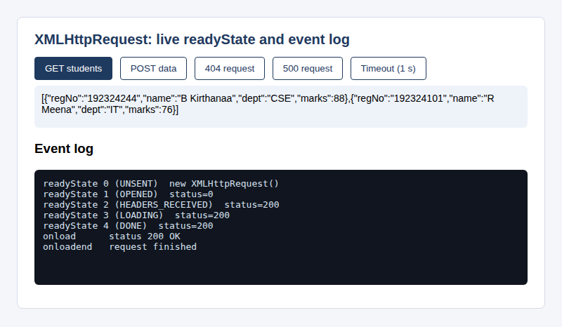
Figure 14: GET students: readyState goes 0, 1, 2, 3, 4 and then onload reports status 200
The log shows all five readyState values in order. The status is 0 at stages 0 and 1, because no reply exists yet, and becomes 200 from stage 2 onwards. onload fires after stage 4 and onloadend fires last.

2. POST request with JSON data
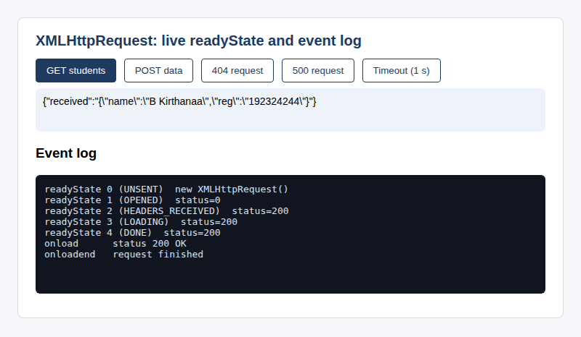
Figure 15: POST data: the server returns the JSON that was sent

3. Request for an address that does not exist
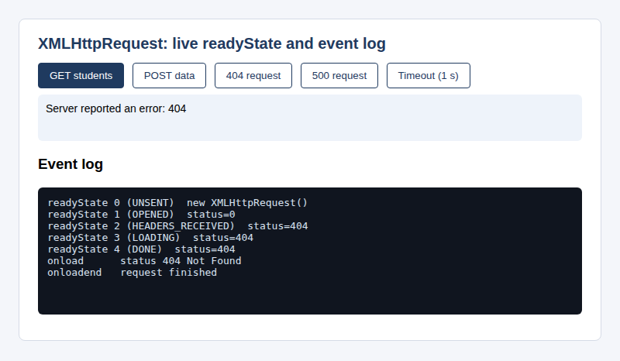
Figure 16: 404 request: the stages still reach 4 and onload fires, so the program must check status
The log shows readyState 4 and onload even though the server answered 404. This is why a successful onload is not enough and status must be tested.

4. Timeout
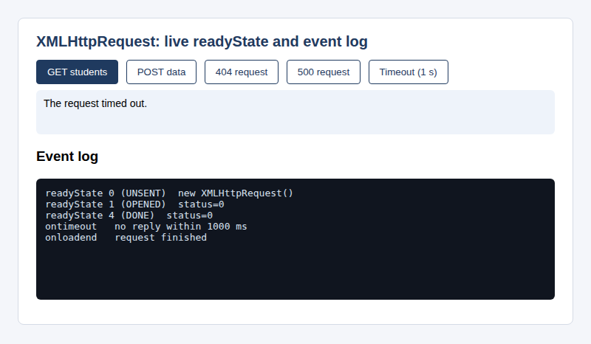
Figure 17: Timeout: readyState jumps from 1 to 4 with status 0 and ontimeout fires
The server was told to wait 3 seconds but the page waited only 1 second. The request jumped from stage 1 to stage 4 with status 0, ontimeout fired, and onload never did.

(e) Testing with valid and invalid data
Five scenarios were run and the event log of each was recorded.
- GET /api/students. Log: readyState 0, 1, 2, 3, 4, then onload with 200 OK, then onloadend. The two student records came back as JSON.
- POST /api/echo. The same sequence with 200 OK. The server returned the JSON text that was posted, which proves that the body and the Content-Type header reached it.
- GET /api/nothing. The sequence 0 to 4 with status 404, then onload with "404 Not Found". The page showed "Server reported an error: 404".
- GET /api/error. The sequence 0 to 4 with status 500, then onload with "500 Internal Server Error". The page showed "Server reported an error: 500".
- GET /api/slow with a 1 second timeout. Log: readyState 0, 1, then 4 with status 0, then ontimeout ("no reply within 1000 ms") and onloadend. There was no stage 2 or 3, because no reply ever arrived.
The tests show that onload fires for every reply the server sends, including error replies, that ontimeout and onerror are used for the cases where no reply comes, and that onloadend fires in every case.

(f) Evaluation and suggested improvements

Strengths
- Every readyState value and every callback is shown in a live log, so the theory can be checked against real behaviour.
- One function serves all the requests, so the code is short and each scenario differs only in its arguments.
- Success, HTTP errors, timeouts and network errors are all handled separately.
- The response is written with textContent, so a reply from the server cannot add HTML to the page.

Limitations
- The program parses nothing. It shows the raw responseText, whereas a real page would call JSON.parse and build elements from the data.
- There is no retry after a failure and no progress bar.
- XMLHttpRequest is callback based, which gets hard to read when one request depends on another.

Suggested improvements
- Parse the JSON reply and display it in a list, as in Question 2.
- Add onprogress to show a progress bar for large downloads.
- Wrap the request in a promise, or use fetch with async and await, for cleaner code.
- Retry a failed request once or twice with a short delay before telling the user.

Question 4: Student Management System using TypeScript Classes and Objects
Question 4 | (10 marks) (CO2) (BL4)
An engineering college plans to develop a Student Management System using TypeScript to manage student information, including name, register number, department and marks. Develop a TypeScript program using a class and object to represent student details. Include properties, a constructor and a method to display student information.
SOLUTION:

(a) Understanding the problem and the requirements
A college keeps the same few facts about every student: the name, the register number, the department and the marks. Writing these as loose variables would quickly become messy once there are hundreds of students. The question asks for a better way: describe a student once as a class, create one object for each real student, and give the class a constructor to fill in the details and a method to display them. The program must be written in TypeScript.

Theory background
What TypeScript is. TypeScript is a language developed by Microsoft that adds static types to JavaScript. Every valid JavaScript program is also valid TypeScript, so it can be learned step by step. A browser or Node.js cannot run TypeScript directly. The compiler tsc checks the program and then translates it into plain JavaScript. The types exist only while the program is being checked and are removed from the output, which is called type erasure.
Why static types help. JavaScript decides the type of a value only when the program runs, so a mistake such as passing text where a number is expected shows up late, often in front of the user. TypeScript reports the same mistake while the code is being written. Editors use the types to offer auto-completion, and a large program becomes easier to change because the compiler points out every place that a change affects. The basic types are string, number, boolean, arrays such as number[], void for a function that returns nothing, and any or unknown when the type is not known. Often the type need not be written, because the compiler works it out from the value, which is called type inference.
Classes and objects. A class is a blueprint. It lists the properties (the data) and the methods (the actions) that every object of that kind will have. An object is one real item made from the blueprint with the keyword new. In a class, this means the object on which the method is running, so two students use the same code but keep their own data.
The constructor. The constructor is a special method named constructor. It runs once, automatically, at the moment an object is created with new. Its job is to give the properties their first values. In TypeScript the parameters of the constructor have types, so new Student("A", "1", "CSE", "high") is rejected by the compiler because the marks are text.
Access modifiers and encapsulation. TypeScript offers public (the default, visible everywhere), private (visible only inside the class) and protected (visible inside the class and its subclasses). The keyword readonly allows a property to be set once, in the constructor, and never changed afterwards. Together they give encapsulation: the data is hidden behind methods that can check it. In this program the marks are private, and the only way to change them is setMarks(), which refuses values outside 0 to 100.
Compiling. tsc reads the settings in tsconfig.json. The option strict turns on the strictest checks, target chooses the JavaScript version of the output and outDir says where the generated .js file goes. The generated file is then run with Node.js.

Requirements derived from the question
- A Student class with the properties name, register number, department and marks.
- A constructor that sets all four properties when an object is created.
- A method that displays the student information.
- Objects created from the class to represent real students.
- The program must compile in TypeScript strict mode without errors.

(b) Design of the solution
The Student class holds the four properties. The register number is readonly, because a student's register number must never change. The marks are private and are reached through getMarks() and setMarks(). The method grade() converts the marks into a grade from A+ to F, and display() prints the details, the grade and the result (PASS when the marks are 50 or more, otherwise FAIL).
A second class, StudentManager, makes the program feel like a small management system. It keeps an array of Student objects and offers add(), showAll(), average() and topper(). The average is found with reduce(), which adds up all the marks, and the topper is the student with the highest marks. The main part of the program creates three students, adds them to the manager and prints the report. It finally tries to give a student 120 marks to show that setMarks() rejects the value.

(c) Implementation
The complete source code is given below. The program was compiled with tsc in strict mode with no errors and then run with Node.js.
q4/student.ts (classes, constructor, methods and objects)
// Student Management System using TypeScript classes and objects
class Student {
readonly registerNumber: string;
name: string;
department: string;
private marks: number;

constructor(name: string, registerNumber: string, department: string, marks: number) {
this.name = name;
this.registerNumber = registerNumber;
this.department = department;
this.marks = marks;
}

getMarks(): number {
return this.marks;
}

setMarks(value: number): void {
if (value < 0 || value > 100) {
throw new Error("Marks must be between 0 and 100");
}
this.marks = value;
}

grade(): string {
if (this.marks >= 90) return "A+";
if (this.marks >= 80) return "A";
if (this.marks >= 70) return "B";
if (this.marks >= 60) return "C";
if (this.marks >= 50) return "D";
return "F";
}

display(): void {
console.log("Name : " + this.name);
console.log("Register Number : " + this.registerNumber);
console.log("Department : " + this.department);
console.log("Marks : " + this.marks);
console.log("Grade : " + this.grade());
console.log("Result : " + (this.marks >= 50 ? "PASS" : "FAIL"));
console.log("-----------------------------------");
}
}

class StudentManager {
private students: Student[] = [];

add(s: Student): void {
this.students.push(s);
}

showAll(): void {
this.students.forEach(s => s.display());
}

average(): number {
const total = this.students.reduce((sum, s) => sum + s.getMarks(), 0);
return total / this.students.length;
}

topper(): Student {
return this.students.reduce((best, s) => (s.getMarks() > best.getMarks() ? s : best));
}
}

const manager = new StudentManager();
manager.add(new Student("B Kirthanaa", "192324244", "Computer Science", 88));
manager.add(new Student("R Meena", "192324101", "Information Technology", 76));
manager.add(new Student("S Arun", "192324377", "Electronics", 45));

console.log("STUDENT DETAILS");
console.log("===================================");
manager.showAll();
console.log("Class average : " + manager.average().toFixed(2));
console.log("Topper : " + manager.topper().name);

const first = new Student("Test User", "192399999", "CSE", 70);
try {
first.setMarks(120);
} catch (e) {
console.log("Rejected : " + (e as Error).message);
}
q4/tsconfig.json (compiler settings)
{
"compilerOptions": {
"target": "ES2020",
"module": "commonjs",
"lib": ["ES2020", "DOM"],
"strict": true,
"outDir": "dist"
},
"files": ["student.ts"]
}

Explanation of the important statements
- readonly registerNumber: string; declares a property that can be set only in the constructor. Any later assignment is a compile-time error.
- private marks: number; hides the marks from code outside the class.
- constructor(name: string, registerNumber: string, department: string, marks: number) gives each property its first value from the arguments. The parameter types are checked at every new Student(...) call.
- setMarks(value: number): void checks that the value is between 0 and 100 and throws an Error if it is not. This is the benefit of encapsulation.
- grade(): string uses a chain of if statements from the highest limit downwards, so the first one that is true decides the grade.
- display(): void prints the details with console.log. The return type void says that it returns nothing.
- private students: Student[] = []; is an array that can hold only Student objects.
- this.students.reduce((sum, s) => sum + s.getMarks(), 0) adds up all the marks, starting from 0, and the average is that total divided by the count.
- const manager = new StudentManager(); and new Student(...) create the objects. manager.add(...) puts each student into the manager.
- (e as Error).message in the catch block tells the compiler that the caught value is an Error, because in strict mode a caught value is of unknown type.

(d) Output
The program was compiled and run in a terminal. The pictures below are screenshots of the real output.

1. Compiling with tsc in strict mode
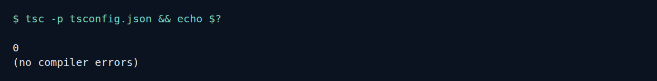
Figure 18: Compilation finished with exit code 0 and no errors

2. Running the compiled program
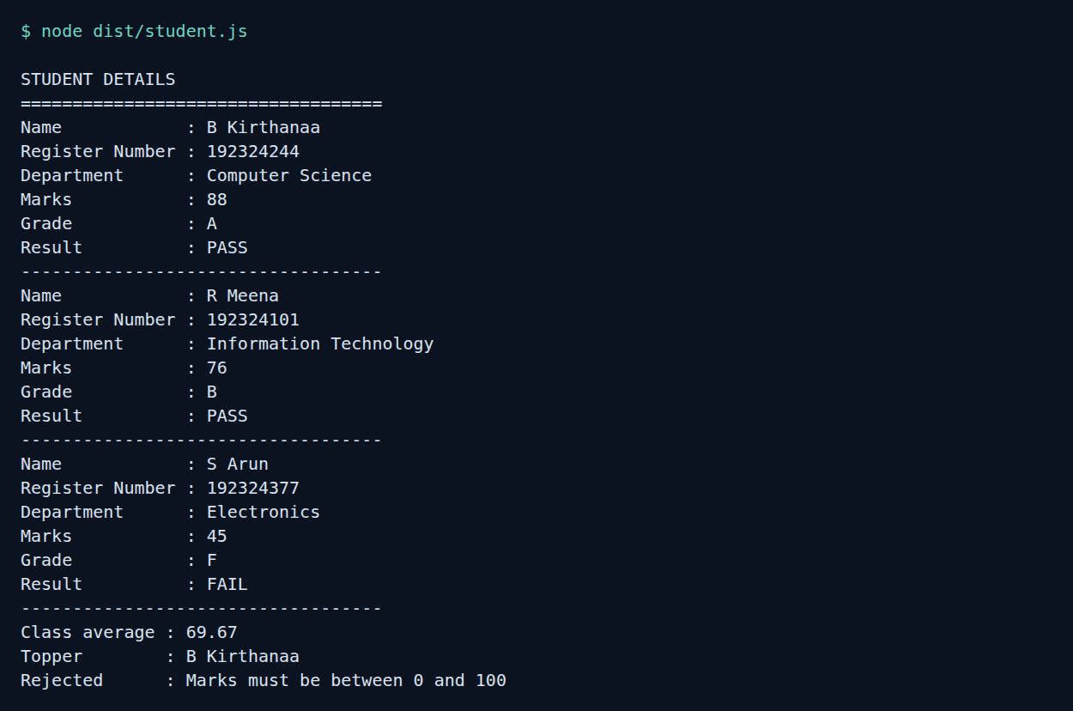
Figure 19: Output of node dist/student.js: three student records, the class average, the topper and the rejected marks value
Each student is shown with a grade and a result. Student number three has 45 marks, so the grade is F and the result is FAIL. The class average is 69.67, calculated as (88 + 76 + 45) / 3. The last line shows setMarks(120) being refused.

(e) Testing with valid and invalid data
Two kinds of testing were done. First, the running program was checked with different marks. The marks 88, 76 and 45 gave the grades A, B and F and the results PASS, PASS and FAIL, which agrees with the grade limits in the code. The average and the topper agree with a hand calculation. A value of 120 was rejected with the message "Marks must be between 0 and 100".
Second, the compiler itself was tested. A small file bad.ts was written with three deliberate mistakes: assigning to the read-only register number, reading the private marks from outside the class, and giving text for the marks. The compiler found all three before any code ran.
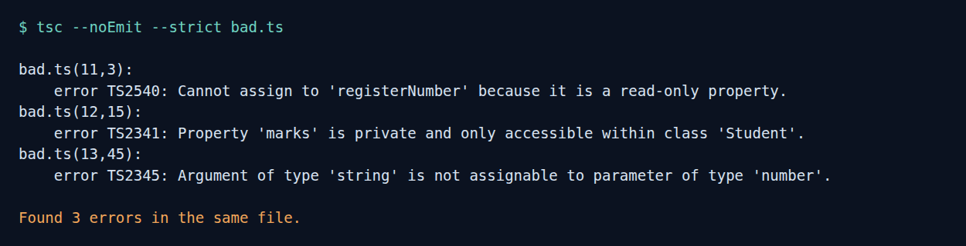
Figure 20: tsc reports all three mistakes in bad.ts at compile time
These messages are the real value of TypeScript. In plain JavaScript the three mistakes would have run silently and produced wrong data.

(f) Evaluation and suggested improvements

Strengths
- The program meets every part of the question: a class, properties, a constructor, a display method and several objects.
- Encapsulation protects the data: the register number cannot be changed and the marks are checked.
- The strict compiler catches type mistakes before the program runs.
- StudentManager shows how objects work together, which is closer to a real system.

Limitations
- The data lives only in memory and is lost when the program ends.
- Only one mark is stored, whereas a real student has many subjects.
- The output goes to the terminal and there is no user interface or input from the user.

Suggested improvements
- Store marks per subject in an array and calculate a percentage or CGPA.
- Define an interface for the data, and use inheritance for different kinds of students such as hosteller and day scholar.
- Save and load the records with a database or a JSON file.
- Check the register number format and reject duplicates in StudentManager.add().

Question 5: Online Banking Form Validation using Regular Expressions
Question 5 | (10 marks) (CO1) (BL3)
Develop a JavaScript-based form validation system for an online banking application. Use Regular Expressions to validate account number, mobile number and email ID.

SOLUTION:

(a) Understanding the problem and the requirements
In an online banking application a wrong value is more serious than on an ordinary form. A mistyped account number can link the wrong account, a wrong mobile number sends one-time passwords to a stranger, and a wrong email ID means the statements never arrive. The form therefore has to check the three values carefully before they are submitted. The question asks for this checking to be done in JavaScript with regular expressions for the account number, the mobile number and the email ID.

Theory background
Why regular expressions suit this job. All three values have a fixed shape. An account number is a run of digits of a limited length, a mobile number is a country prefix and ten digits, and an email ID is a local part, an @ sign and a domain. Regular expressions describe such shapes in one line, so one pattern can replace a long set of if statements. They are also the same in many languages, so the same pattern can be used again in the server code.
The shape of each value. Bank account numbers in India have no single length. Depending on the bank they commonly have between 9 and 18 digits, and they do not begin with zero in this form. An Indian mobile number has 10 digits and the first digit is 6, 7, 8 or 9. People often write it with a prefix such as +91, 91 or 0, so the pattern allows these. An email ID follows the simple form local@domain.tld. The full email standard (RFC 5322) allows many unusual addresses, and a pattern that tries to cover all of it becomes unreadable, so practical forms check the common shape and then confirm the address by sending a mail.
Normalise first, then validate. People type account numbers with spaces or hyphens, as in 1234 5678 9012, because that is how they appear on a card or a passbook. Rejecting this would be unfriendly. The program first removes spaces and hyphens and then applies the pattern. Normalising before validating is a common habit in good form design.
Banking-specific care. The form should tell the user what is wrong, but it should not display or store the full account number longer than needed. After the details are accepted the program shows the account number masked, with only the last four digits visible. Validation in the browser is only a first filter. The server must validate again, and the data must travel over HTTPS, because anything in the browser can be changed by the user or by an attacker.
Choosing patterns carefully. A pattern that is too loose lets wrong values through. A pattern that is too strict rejects real customers. Patterns with nested repeats such as (a+)+ can also take a very long time on certain input, which is called catastrophic backtracking or ReDoS. The patterns here use simple character classes with fixed or bounded repeats, so they run in a short time.

Requirements derived from the question
- Validate the account number with a regular expression.
- Validate the mobile number with a regular expression and accept the usual +91 form.
- Validate the email ID with a regular expression.
- Show clear messages without reloading the page, and show the account number masked after success.

(b) Design of the solution
The three patterns are listed below. The account pattern is ^[1-9]\d{8,17}$: a first digit from 1 to 9 followed by 8 to 17 more digits, which gives 9 to 18 digits in total. The mobile pattern is ^(?:\+91[\s-]?|91[\s-]?|0)?[6-9]\d{9}$: an optional prefix (+91 with an optional space or hyphen, 91, or 0), then a first digit from 6 to 9 and nine more digits. The email pattern is ^[A-Za-z0-9._%+-]+@(?:[A-Za-z0-9-]+\.)+[A-Za-z]{2,}$: a local part, the @ sign, one or more domain labels each followed by a dot, and a top-level domain of at least two letters.
The code is divided into three files. rules.js has the patterns and the checking functions, and it does not touch the page, so it can also be run with Node.js for testing. ui.js connects the form to the rules: it checks a field when the user leaves it, re-checks while the user corrects it, and checks everything on submit. index.html holds the structure and the styles. Each checking function returns an empty string for a valid value or a specific message, such as "Account number cannot start with 0.", for an invalid one.
The functions test simple conditions first (empty, digits only, first digit, length) and use the regular expression as the last check. This gives the user a precise message instead of a general "invalid".

(c) Implementation
The complete source code is given below.
q5/index.html (structure and styles)
<!DOCTYPE html>
<html lang="en">
<head>
<meta charset="UTF-8">
<meta name="viewport" content="width=device-width, initial-scale=1">
<title>Online Banking Registration</title>
<style>
body { font-family: Arial, sans-serif; background: #eef2f7; margin: 0; padding: 24px; }
.card { max-width: 440px; margin: auto; background: #fff; padding: 22px 26px; border-radius: 8px; border: 1px solid #cfd7e3; }
h1 { font-size: 20px; color: #123a63; margin-top: 0; }
label { display: block; font-weight: bold; font-size: 14px; margin-top: 14px; }
input { width: 100%; padding: 9px; font-size: 15px; margin-top: 4px; box-sizing: border-box; border: 1.5px solid #9aa5b8; border-radius: 4px; }
input.bad { border-color: #c62828; background: #fff6f6; }
input.good { border-color: #2e7d32; }
.msg { color: #c62828; font-size: 13px; min-height: 16px; margin-top: 3px; }
button { margin-top: 18px; padding: 10px 20px; background: #123a63; color: #fff; border: 0; border-radius: 4px; font-size: 15px; cursor: pointer; }
#done { margin-top: 14px; font-size: 14px; padding: 0; }
#done.ok { color: #1b5e20; background: #e8f5e9; padding: 10px; border-radius: 4px; }
#done.err { color: #b71c1c; background: #fdecea; padding: 10px; border-radius: 4px; }
</style>
</head>
<body>
<div class="card">
<h1>Online Banking: Link Your Account</h1>
<form id="bank" novalidate>
<label for="account">Account number</label>
<input id="account" type="text" inputmode="numeric" autocomplete="off">
<div class="msg" id="account-msg" aria-live="polite"></div>

<label for="mobile">Mobile number</label>
<input id="mobile" type="text" inputmode="tel" autocomplete="off">
<div class="msg" id="mobile-msg" aria-live="polite"></div>

<label for="email">Email ID</label>
<input id="email" type="text" autocomplete="off">
<div class="msg" id="email-msg" aria-live="polite"></div>

<button type="submit">Submit details</button>
<div id="done" aria-live="polite"></div>
</form>
</div>
<script src="rules.js"></script>
<script src="ui.js"></script>
</body>
</html>
q5/rules.js (regular expressions and rules)
// Validation rules for the online banking form (Question 5)
const PATTERNS = {
// 9 to 18 digits, the first digit must not be zero
account: /^[1-9]\d{8,17}$/,
// optional +91 or 91 or 0 prefix, then a 10 digit number starting with 6 to 9
mobile: /^(?:\+91[\s-]?|91[\s-]?|0)?[6-9]\d{9}$/,
// local part, @, domain labels, top-level domain of at least 2 letters
email: /^[A-Za-z0-9._%+-]+@(?:[A-Za-z0-9-]+\.)+[A-Za-z]{2,}$/
};

function checkAccount(value) {
const v = value.replace(/[\s-]/g, "");
if (v === "") return "Account number is required.";
if (/\D/.test(v)) return "Account number must contain digits only.";
if (v[0] === "0") return "Account number cannot start with 0.";
if (v.length < 9 || v.length > 18) return "Account number must have 9 to 18 digits.";
return PATTERNS.account.test(v) ? "" : "Account number is not valid.";
}

function checkMobile(value) {
const v = value.trim();
if (v === "") return "Mobile number is required.";
return PATTERNS.mobile.test(v) ? "" : "Enter a 10 digit Indian mobile number starting with 6, 7, 8 or 9.";
}

function checkEmail(value) {
const v = value.trim();
if (v === "") return "Email ID is required.";
if (!v.includes("@")) return "Email ID must contain the @ symbol.";
if (v.includes("..")) return "Email ID cannot contain two dots in a row.";
return PATTERNS.email.test(v) ? "" : "Enter an email ID such as name@example.com.";
}

function maskAccount(value) {
const v = value.replace(/[\s-]/g, "");
return "X".repeat(v.length - 4) + v.slice(-4);
}

if (typeof module !== "undefined") {
module.exports = { PATTERNS, checkAccount, checkMobile, checkEmail, maskAccount };
}
q5/ui.js (DOM and events)
// Interface code for the banking form: reads the fields, shows messages
const form = document.getElementById("bank");
const fields = [
{ id: "account", check: checkAccount },
{ id: "mobile", check: checkMobile },
{ id: "email", check: checkEmail }
];

function validateField(f) {
const input = document.getElementById(f.id);
const msg = document.getElementById(f.id + "-msg");
const problem = f.check(input.value);
msg.textContent = problem;
input.classList.toggle("bad", problem !== "");
input.classList.toggle("good", problem === "" && input.value !== "");
input.setAttribute("aria-invalid", problem !== "");
return problem === "";
}

fields.forEach(f => {
const input = document.getElementById(f.id);
input.addEventListener("blur", () => validateField(f));
input.addEventListener("input", () => { if (input.classList.contains("bad")) validateField(f); });
});

form.addEventListener("submit", event => {
event.preventDefault(); // stay on the same page
const okList = fields.map(validateField);
const done = document.getElementById("done");
if (okList.every(Boolean)) {
done.className = "ok";
done.textContent = "Details accepted. Account " + maskAccount(document.getElementById("account").value) +
" is linked to the mobile number and email ID given.";
} else {
done.className = "err";
done.textContent = okList.filter(x => !x).length + " field(s) need your attention.";
document.querySelector(".bad").focus();
}
});
q5/test.js (regex test script)
const { checkAccount, checkMobile, checkEmail } = require("./rules.js");
const cases = [
["Account", checkAccount, "123456789", true],
["Account", checkAccount, "1234 5678 9012 3456", true],
["Account", checkAccount, "921020012345678", true],
["Account", checkAccount, "12345678", false],
["Account", checkAccount, "1234567890123456789", false],
["Account", checkAccount, "0123456789", false],
["Account", checkAccount, "12345A789", false],
["Account", checkAccount, "", false],
["Mobile", checkMobile, "9876543210", true],
["Mobile", checkMobile, "+91 9876543210", true],
["Mobile", checkMobile, "+91-6123456789", true],
["Mobile", checkMobile, "09876543210", true],
["Mobile", checkMobile, "5876543210", false],
["Mobile", checkMobile, "98765 4321", false],
["Mobile", checkMobile, "98765432101", false],
["Mobile", checkMobile, "abcdefghij", false],
["Email", checkEmail, "kirthanaa@simats.edu", true],
["Email", checkEmail, "b.kirthanaa+bank@mail.example.co.in", true],
["Email", checkEmail, "kirthanaa@", false],
["Email", checkEmail, "kirthanaa.simats.edu", false],
["Email", checkEmail, "kirthanaa@simats", false],
["Email", checkEmail, "kirth..anaa@simats.edu", false],
["Email", checkEmail, "@simats.edu", false],
["Email", checkEmail, "kirthanaa@simats.c", false]
];
let pass = 0;
cases.forEach(([field, fn, input, shouldPass], i) => {
const accepted = fn(input) === "";
const ok = accepted === shouldPass;
if (ok) pass++;
console.log(String(i + 1).padStart(2) + ". " + field.padEnd(8) + JSON.stringify(input).padEnd(40) +
(accepted ? "accepted" : "rejected").padEnd(10) + (ok ? "PASS" : "FAIL"));
});
console.log("\n" + pass + " of " + cases.length + " test cases passed");

Explanation of the important statements
- const PATTERNS = { account: /.../, mobile: /.../, email: /.../ } keeps every pattern in one place with a clear name.
- value.replace(/[\s-]/g, "") removes spaces and hyphens from the account number before it is checked. The g flag makes it replace every occurrence and not only the first.
- /\D/.test(v) finds any character that is not a digit, so the user gets the message "digits only" instead of a general error.
- v[0] === "0" is a separate test for a leading zero, so the message can say exactly what is wrong.
- PATTERNS.mobile.test(v) returns true only for a ten-digit number that starts with 6 to 9, with or without the +91, 91 or 0 prefix.
- maskAccount(value) builds a string of X characters with "X".repeat(n) and adds the last four digits with slice(-4).
- input.classList.toggle("bad", problem !== "") switches the red border on and off from the result of the rule.
- form.addEventListener("submit", event => { event.preventDefault(); ... }) stops the form from being sent, so the checks happen in the same page without a reload.
- document.querySelector(".bad").focus() moves the cursor to the first wrong field.
- if (typeof module !== "undefined") module.exports = {...} lets Node.js load rules.js for testing, while the browser ignores the line.

(d) Output
The page was opened in a browser and the following situations were tried. Every figure is a screenshot of the running program.

1. The form when it is first opened
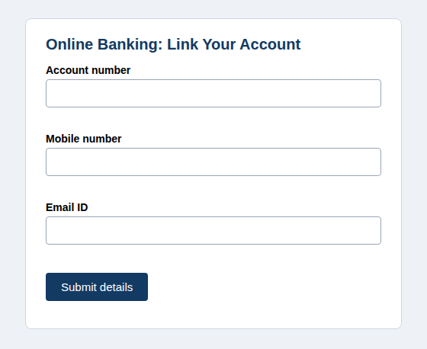
Figure 21: The banking form on first load: three empty fields and no messages

2. Submitting with all fields empty
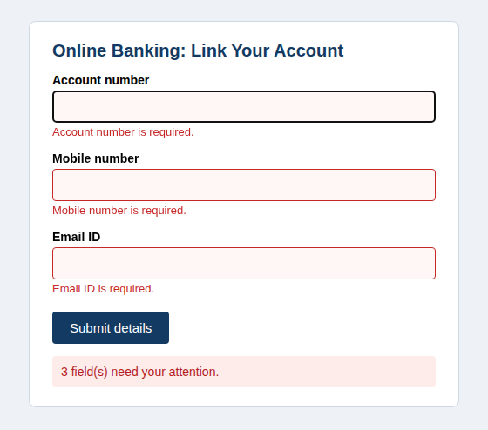
Figure 22: Submit with empty fields: every field shows its required message and the summary says 3 fields need attention

3. Submitting with invalid values
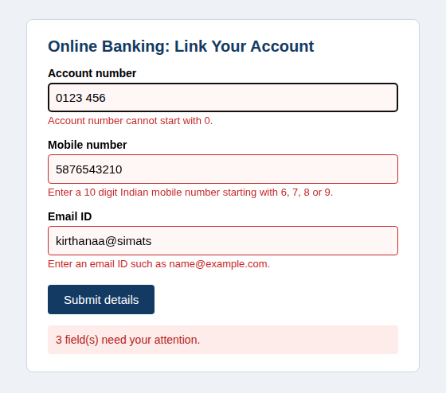
Figure 23: Invalid data: each field shows a message that names the specific mistake
The values entered were 0123 456 (starts with 0), 5876543210 (first digit 5) and kirthanaa@simats (no top-level domain). Each field turned red and received its own message.

4. Submitting valid values
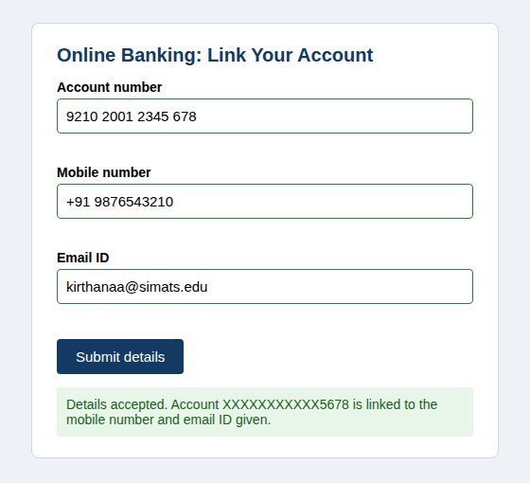
Figure 24: Valid data: green borders and a confirmation that shows the account number masked
The account number was typed as 9210 2001 2345 678 with spaces, the mobile number as +91 9876543210 and the email as kirthanaa@simats.edu. All three were accepted, and the confirmation shows the account number as X characters followed by the last four digits.

5. Regular expression test run
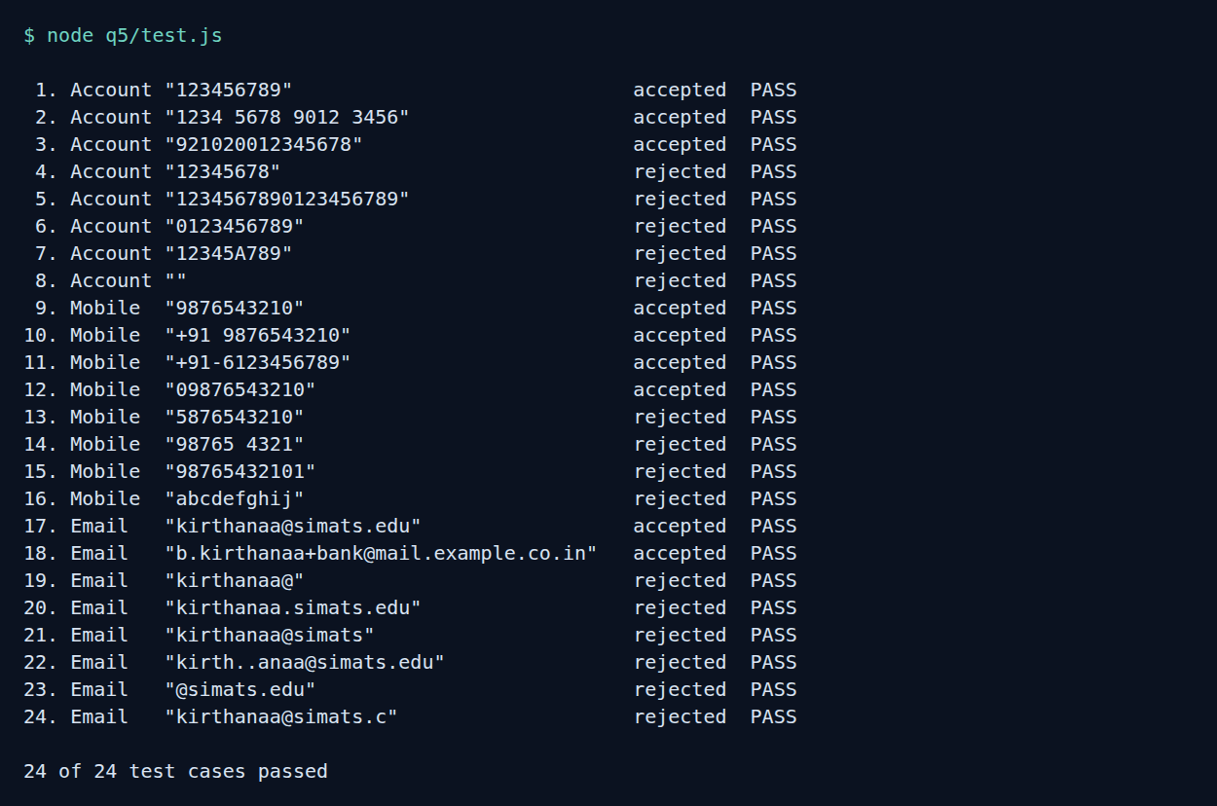
Figure 25: Output of node q5/test.js: 24 of 24 test cases passed

(e) Testing with valid and invalid data
The rules in rules.js do not depend on the page, so they were tested in Node.js with 24 inputs, eight for each field. All 24 gave the expected result.
- Account number. Accepted: 123456789 (the shortest valid length), 1234 5678 9012 3456 (spaces are removed first) and 921020012345678. Rejected: 12345678 (8 digits, too short), a 19-digit number (too long), 0123456789 (starts with zero), 12345A789 (contains a letter) and an empty box.
- Mobile number. Accepted: 9876543210, +91 9876543210, +91-6123456789 and 09876543210. Rejected: 5876543210 (first digit 5), 98765 4321 (too few digits), 98765432101 (eleven digits) and abcdefghij.
- Email ID. Accepted: kirthanaa@simats.edu and b.kirthanaa+bank@mail.example.co.in. Rejected: kirthanaa@ (no domain), kirthanaa.simats.edu (no @), kirthanaa@simats (no top-level domain), kirth..anaa@simats.edu (double dot), @simats.edu (no local part) and kirthanaa@simats.c (top-level domain of one letter).

(f) Evaluation and suggested improvements

Strengths
- All three fields are validated with regular expressions, as the question requires, and the page is never reloaded.
- Spaces and hyphens in the account number are accepted and removed, which is friendly to the user.
- Messages are specific, and the confirmation shows the account number masked, which is better for privacy.
- The patterns are simple and bounded, so they cannot cause very slow matching.

Limitations
- A pattern can only check the shape of a value. It cannot tell whether the account really exists or whether the mobile number belongs to the user.
- Account number lengths differ between banks, and the form uses one general range of 9 to 18 digits.
- The email pattern does not accept every address that the full standard allows, such as quoted local parts.

Suggested improvements
- Repeat all checks on the server and send the data only over HTTPS.
- Confirm the mobile number with an OTP and the email ID with a verification link.
- Check the account number against the bank's own rules, for example its IFSC code and length, on the server.
- Suggest a correction for common typing mistakes in the email domain, such as gmial.com.

Code of Conduct and Rubrics
Code of Conduct:
I B KIRTHANAA 192324244 certify that this submission is my original work and that I have adhered to the guidelines specified for this assessment. I understand that any violation of academic integrity rules will result in disciplinary action.
Signature of the student: B KIRTHANAA

RUBRICS FOR CALCULATION:
Criteria | Weightage (%) | Level 4 - Exemplary (4) | Level 3 - Proficient (3) | Level 2 - Developing (2) | Level 1 - Beginning (1)
Understanding of Concept | 25 | Demonstrates complete understanding of design requirements and concepts | Good understanding with minor gaps | Basic understanding with some errors | Poor understanding or incorrect concepts
Design / Implementation | 30 | Well-structured, efficient, and responsive design implementation | Correct implementation with minor issues | Basic implementation with inconsistencies | Incorrect or incomplete implementation
Use of Tools (CSS/JS) | 20 | Effective and advanced use of tools/techniques | Appropriate use of tools | Limited or inconsistent use | Incorrect or minimal use
Analysis & Evaluation | 15 | Insightful analysis with strong justification and optimization | Good analysis with justification | Basic analysis with limited depth | Poor or no analysis
Documentation / Clarity | 10 | Clear, well-structured, and properly presented solution | Mostly clear with minor issues | Basic clarity, missing details | Poor or unclear documentation

